1. **Introduction to Project**
   1. **Introduction:**

In this modern age where urbanization and increasing vehicle numbers contribute to traffic congestion, environmental pollution, and high commuting costs, efficient transportation solutions have become a necessity. Our project aims to address these challenges by providing a smart and sustainable carpooling and ride-sharing platform.

Whether it's daily commuting to workplaces, educational institutions, or intercity travel, a well-designed ride-sharing system can significantly ease the burden on existing transportation networks. Through this project, we intend to develop a user-friendly and technologically advanced application that connects drivers with empty car seats to passengers traveling along the same route.

Our system will offer features such as real-time ride booking and tracking, route optimization using geolocation and mapping services, secure payment integration, ride history management, and alert notifications. Additionally, the application will support user authentication, rating systems for safety and trust, and fare calculations based on distance and ride-sharing parameters.

By implementing our Carpooling and Ride-Sharing Application, users can expect reduced travel costs, minimized environmental impact through lower emissions, less traffic congestion, and a convenient, safe commuting experience - ultimately contributing to a smarter and greener future.

* 1. **Introduction of Existing System:**
     + The existing carpooling and ride-sharing systems often involve informal arrangements, basic mobile communication, and traditional methods of coordination between riders and drivers.
     + Typically, ride coordination is done manually through word of mouth, messaging apps, or basic social media groups. While functional on a small scale, this process is inefficient, lacks scalability, and is prone to miscommunication or scheduling conflicts.
     + Route and fare management are often handled manually or based on mutual agreement, without proper optimization for time, distance, or cost efficiency. This leads to underutilized routes and unequal fare sharing.
     + Safety and reliability remain concerns, as there is often no proper mechanism to verify driver or passenger identities, nor any established feedback or rating system to ensure trust and accountability.
     + Payment transactions, if any, are usually handled in cash, without integration into digital platforms, leading to inconvenience and lack of transparency.
  2. **Need and scope of System:**
* **Efficient Ride and User Management:** With increasing urban traffic and fuel costs, a dedicated carpooling system is essential to organize rides efficiently. The system will manage user profiles, match drivers and riders based on routes, and optimize ride-sharing opportunities to ensure cost-effective and eco-friendly commuting.
* **Enhanced User Experience and Satisfaction:** A well-designed ride-sharing platform ensures timely pickups, safe travel, and convenience for both drivers and passengers. Features such as real-time tracking, secure payments, user ratings, and smart notifications help build trust and improve user satisfaction, encouraging continued use of the service.
* **Operational Efficiency and Scalability:** Automating ride-matching, fare calculation, and route optimization minimizes manual coordination and errors. Integration with third-party services like Google Maps for navigation and Razorpay for digital payments enhances the functionality of the system. The platform also supports scalability, allowing it to be expanded across cities or campuses with minimal adjustments.

1. **Proposed System**
   1. **Objectives:**
      * The primary objective of the carpooling and ride-sharing system is to optimize the process of connecting drivers and passengers traveling along similar routes. This includes efficient ride matching, route optimization, and minimizing vacant car seats to ensure better resource utilization.
      * Another key objective is to promote cost-effective and eco-friendly transportation solutions by reducing the number of vehicles on the road, thereby decreasing fuel consumption, traffic congestion, and environmental pollution.
      * The system aims to enhance operational efficiency by automating core functions such as ride booking, fare calculation, route tracking, and payment processing. Real-time GPS tracking, digital payments, and smart notifications reduce manual coordination and improve reliability.
      * The ride-sharing platform also strives to improve user satisfaction and safety by offering features like secure user authentication, ride history, driver/passenger ratings, and timely alerts. These contribute to building trust among users, encouraging long-term engagement and a positive user experience.

**2.2 Requirement Engineering:**

**Requirements Engineering (RE)** refers to the process of defining, documenting, and maintaining requirements in the engineering design process. Requirement engineering provides the appropriate mechanism to understand what the customer desires, analyzing the need, and assessing feasibility, negotiating a reasonable solution, specifying the solution clearly, validating the specifications and managing the requirements as they are transformed into a working system. Thus, requirement engineering is the disciplined application of proven principles, methods, tools, and notation to describe a proposed system's intended behavior and its associated constraints.

### **Feasibility Study:**

### The objective behind the feasibility study is to create the reasons for developing the software that is acceptable to users, flexible to change and conformable to established standards.

* **Technical Feasibility** - Technical feasibility evaluates the current technologies, which are needed to accomplish customer requirements within the time and budget.
* **Operational Feasibility** - Operational feasibility assesses the range in which the required software performs a series of levels to solve business problems and customer requirements.
* **Economic Feasibility** - Economic feasibility decides whether the necessary software can generate financial profits for an organization.

### **Requirement Elicitation and Analysis:**

This is also known as the **gathering of requirements**. Here, requirements are identified with the help of customers and existing systems processes, if available. Analysis of requirements starts with requirement elicitation. The requirements are analyzed to identify inconsistencies, defects, omission, etc. We describe requirements in terms of relationships and also resolve conflicts if any.

**Problems of Elicitation and Analysis:**

* Getting all, and only, the right people involved.
* Stakeholders often don't know what they want
* Stakeholders express requirements in their terms.
* Stakeholders may have conflicting requirements.
* Requirement change during the analysis process.
* Organizational and political factors may influence system requirements.

**2.2.1 Requirement Gathering:**

To gather your requirements, use the following six-step process. Once you’re finished, you should have a comprehensive requirements document outlining the resources you need to move forward through the [project phases](https://asana.com/resources/project-management-phases).

### **Step 1: Assign Roles**

When we have design application to find first step in requirements gathering is to assign roles in our project. we have identified our [stakeholders](https://asana.com/resources/project-stakeholder). A stakeholder is anyone invested in the project, whether they’re internal or external partners.

**Step 2: Meet with Stakeholders**

Once we’ve identified our project stakeholders, we meet with them to understand what they’re hoping to achieve from the project. It’s important for us to understand their expectations because they are the ones we’re ultimately creating our deliverables for.

As we talk with stakeholders, we ask questions that help us create a comprehensive list of requirements.

**Step 3: Gather and Document**

This step happens alongside meeting with stakeholders. While we’re asking questions and engaging in discussions, we gather and document as much information as possible.

Our goal is to capture everything we can, so we’re prepared when it’s time to start the project. We use project management tools to keep all this information organized—our project plan, requirements, and communication are all in one place.

Some examples of what we might document include:

• Stakeholder answers to our interview questions

• Questions stakeholders ask

• Stakeholder requests

• Stakeholder comments

• Additional questions and insights that come up during interviews

Even if we don’t end up using every answer, having all the information helps us understand every stakeholder’s perspective, which is essential for effective requirements management.

**Step 4: List Assumptions and Requirements**

Once we’ve completed our information gathering, we create a requirements management plan based on what we’ve learned. We review the initial questions we set out to answer during the requirements gathering process and use those insights to define our project requirements. These include:

* Length of Project Schedule: We map out the timeline, often using tools like Gantt charts to visualize dependencies and milestones. Some requirements will span the entire project, like budget for team salaries, while others may only apply at specific stages, such as the need for certain materials toward the end.
* People Involved in the Project: We identify the exact team members we’ll need for the project—how many designers, developers, managers, and other roles are essential for executing each step. If we don’t have the right team in place, we risk delays.
* Project Risks: We analyze risks by using a risk register and brainstorming sessions. We prioritize risks such as stakeholder feedback delays, timeline issues, and budget constraints. Our goal is to prevent risks where possible and be prepared to address them when they arise.

We ensure our project requirements are actionable, measurable, and detailed-outlining the project budget, timeline, resources, and team with as much clarity as possible.

**Step 5: Get Approval**

Once we’ve formalized our project requirements, we seek approval from stakeholders. This step ensures we’re aligned with user needs and helps us avoid scope creep by clearly defining the project’s boundaries from the start. After approval, we move forward with the implementation phase—acquiring resources and assembling the team.

**Step 6: Monitor Progress**

The final step is to monitor the progress of our project. We use project management software to track our budget, timeline, and requirements throughout execution. The advantage of these tools is that we can see changes in real time and take immediate action when necessary.

### **2.2.2 Software Requirement Specification:**

Software requirement specification is a kind of document which is created by a software analyst after the requirements collected from the various sources - the requirement received by the customer written in ordinary language. It is the job of the analyst to write the requirement in technical language so that they can be understood and beneficial by the development team.

The models used at this stage include ER diagrams, data flow diagrams (DFDs), function decomposition diagrams (FDDs), data dictionaries, etc.

* **Data Flow Diagrams:** Data Flow Diagrams (DFDs) are used widely for modeling the requirements. DFD shows the flow of data through a system. The system may be a company, an organization, a set of procedures, a computer hardware system, a software system, or any combination of the preceding. The DFD is also known as a data flow graph or bubble chart.
* **Data Dictionaries:** Data Dictionaries are simply repositories to store information about all data items defined in DFDs. At the requirements stage, the data dictionary should at least define customer data items, to ensure that the customer and developers use the same definition and terminologies.
* **Entity-Relationship Diagrams:** Another tool for requirement specification is the entity-relationship diagram, often called an "E-R diagram." It is a detailed logical representation of the data for the organization and uses three main constructs i.e. data entities, relationships, and their associated attributes

### **Software Requirement Validation:**

After requirement specifications developed, the requirements discussed in this document are validated. The user might demand illegal, impossible solution or experts may misinterpret the needs.

Requirements can be the check against the following conditions -

* If they can practically implement
* If they are correct and as per the functionality and specially of software
* If there are any ambiguities
* If they are full
* If they can describe

### **Software Requirement Management:**

Requirement management is the process of managing changing requirements during the requirements engineering process and system development. New requirements emerge during the process as business needs a change, and a better understanding of the system is developed. The priority of requirements from different viewpoints changes during development process. The business and technical environment of the system changes during the development.

### **3.1 System Diagram:**

### **3.1.1 DFD**:

**Context Level DFD:**

**First Level DFD:**

**RideSync**

**User/Driver**

**Admin**

**2**

**. To give login pass**

**4**

**. To book/accept ride successfully**

**3**

**. User/ Driver sign in & book / accept ride**

**1**

**. request for registration**

**5**

**. Login**

**7. Admin Driver Verification & Management**

**6**

**. login Successful**

1.0

Login

Admin

1.1

Overview

1.2

Ride

Details

1.3

Revenue

1.4

User

Engagement

1.5

Driver

Details

Driver db

User db

Payment db

Ride db

Ridesync db

**Second Level DFD:**

1.0

Login

1.1

Ride

1.2

Payment

User / Driver

Login Details

Ride Details

Payment Details

### **3.1.2 ERD:**

**registrationstatus**

**rcbook**

**pincode**

**VehicleDetails**

**carinsurance**

**carimg**

**aadhaarimg**

**id**

**vehicletype**

**vehiclemodel**

**vehicledetails**

**vehiclecolor**

**rcbookimg**

**pancardimg**

**capacity**

**has**

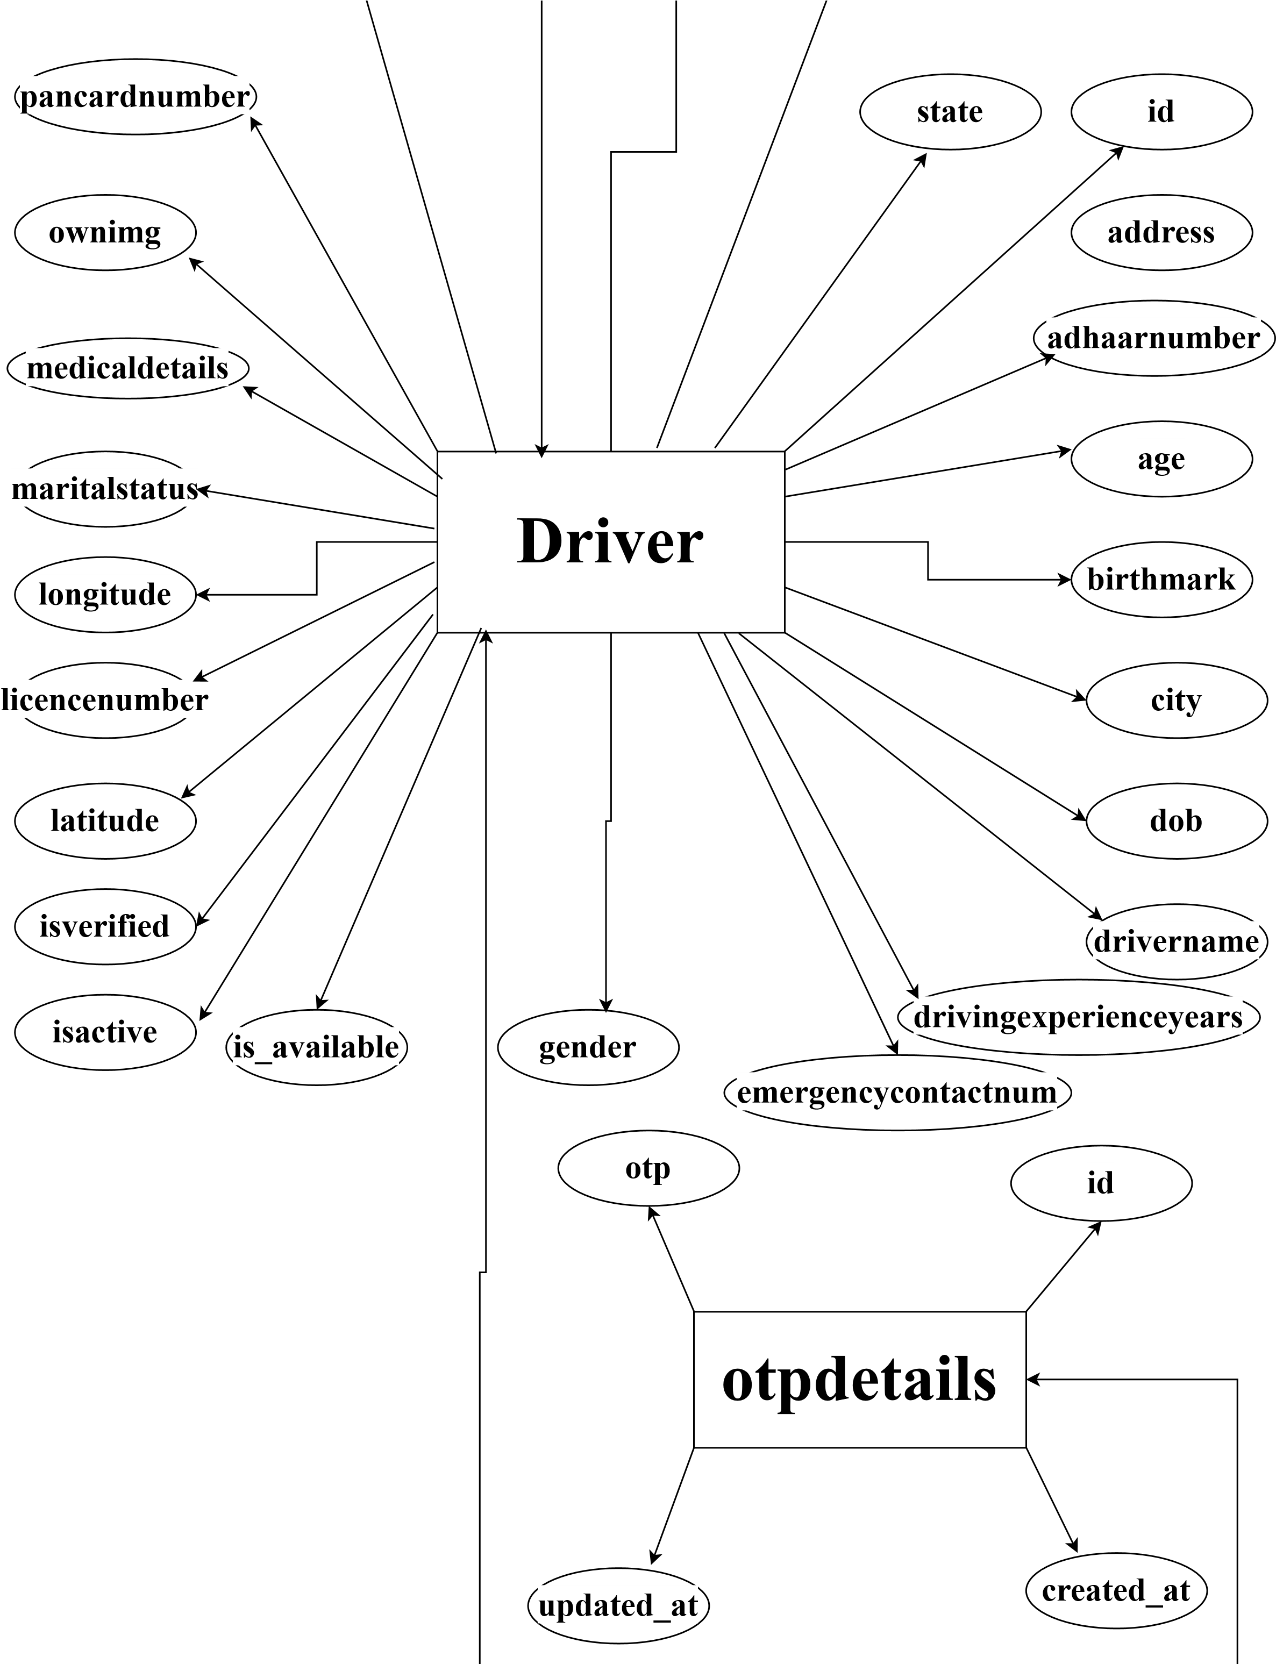

**Signup**

**user**

**id**

**pincode**

**address**

**city**

**name**

**state**

**role**

**phone**

**id**

**has**

**has**

**Booking_Entity**

**id**

**u_lontitude**

**u_lattitude**

**d_longitude**

**d_latitude**

**tolatitude**

**tolontatude**

**userid**

**tolantatude**

**driver_name**

**totalkm**

**bookingdate**

**status**

**price**

**bookingstatus**

**bookingtime**

**bookingtype**

**payment_id**

**payment**

**is_allocated**

**capacity**

**code**

**fromlontatude**

**fromlatude**

**driverid**

### **4.1 Database Design**:

* + 1. **Table Name: Signup**

|  |  |  |  |
| --- | --- | --- | --- |
| **System Name:** Application for Carpooling and Ridesharing | | | |
| **Table Name:** signup | | | |
| Sr. No. | Field Name | Data Type | Description |
| 1 | id | int(11) | Insert userid |
| 2 | phone | Varchar(255) | Enter the phone number |
| 3 | role | Varchar(255) | To store role of user |

* + 1. **Table Name: Vehicle_details**

|  |  |  |  |
| --- | --- | --- | --- |
| **System Name:** Application for Carpooling and Ridesharing | | | |
| **Table Name:** vehicledetails | | | |
| Sr. No. | Field Name | Data Type | Description |
| 1 | id | int | Insert id |
| 2 | aadhaarimg | varchar(255) | To store aadhar image |
| 3 | carimg | varchar(255) | To store car image |
| 4 | carinsurance | varchar(255) | To store car insurance |
| 5 | pancardimg | varchar(255) | To store pan card image |
| 6 | rcbookimg | varchar(255) | To store rc book image |
| 7 | vehiclecolor | varchar(255) | To store vehicle color |
| 8 | vehicledetails | varchar(255) | To store vehicle details |
| 9 | vechilemodel | varchar(255) | To store vehicle model |
| 10 | vechiletype | varchar(255) | To store vehicle type |
| 11 | capacity | varchar(255) | To store capacity |
| **Report:** Vehicles | | | |

* + 1. **Table Name: User_details**

|  |  |  |  |
| --- | --- | --- | --- |
| **System Name:** Application for Carpooling and Ridesharing | | | |
| **Table Name:** userinfo | | | |
| Sr. No. | Field Name | Data Type | Description |
| 1 | id | int | Insert item id |
| 2 | address | varchar(255) | To store user address |
| 3 | city | varchar(255) | To store city |
| 4 | name | varchar(255) | To store name |
| 5 | pincode | bigint(20) | To store pincode |
| 6 | state | varchar(255) | To store state |
| **Report:** Users | | | |

* + 1. **Table Name: OTP_Details**

|  |  |  |  |
| --- | --- | --- | --- |
| **System Name:** Application for Carpooling and Ridesharing | | | |
| **Table Name:** otpdetails | | | |
| Sr. No. | Field Name | Data Type | Description |
| 1 | id | int | Insert id |
| 2 | created_at | datetime(6) | To store created at date |
| 3 | otp | int | To store otp |
| 4 | updated_at | datetime(6) | To store updated at date |
| **Report:** User Engagement | | | |

* + 1. **Table Name: Driver_Details**

|  |  |  |  |
| --- | --- | --- | --- |
| **System Name:** Application for Carpooling and Ridesharing | | | |
| **Table Name:** driver | | | |
| Sr. No. | Field Name | Data Type | Description |
| 1 | id | int(11) | Unique identifier for the driver |
| 2 | address | varchar(255) | Driver’s address |
| 3 | adhaarnumber | varchar(255) | Aadhaar number of the driver |
| 4 | age | int(11) | Age of the driver |
| 5 | birthmark | varchar(255) | Any visible birthmark |
| 6 | city | varchar(255) | City name |
| 7 | dob | varchar(255) | Date of birth |
| 8 | drivername | varchar(255) | Name of the driver |
| 9 | drivingexperienceyears | int(11) | Years of driving experience |
| 10 | emergencycontactnum | varchar(255) | Emergency contact number |
| 11 | gender | varchar(255) | Gender of the driver |
| 12 | is_available | bit(1) | Availability status |
| 13 | isactive | bit(1) | Active status |
| 14 | isverified | bit(1) | Verification status |
| 15 | latitude | varchar(255) | Driver's current latitude |
| 16 | licencenumber | varchar(255) | Driver's license number |
| 17 | longitude | varchar(255) | Driver's current longitude |
| 18 | maritalstatus | varchar(255) | Marital status |
| 19 | medicaldetails | varchar(255) | Any medical information |
| 20 | ownimg | varchar(255) | Link to driver’s profile image |
| 21 | pancardnumber | varchar(255) | PAN card number |
| 22 | pincode | varchar(255) | Area pincode |
| 23 | rcbook | varchar(255) | RC book number |
| 24 | registrationstatus | varchar(255) | Registration status |
| 25 | state | varchar(255) | State name |
| **Report:** Drivers | | | |

* + 1. **Table Name: Booking_Details**

|  |  |  |  |
| --- | --- | --- | --- |
| **System Name:** Application for Carpooling and Ridesharing | | | |
| **Table Name:** booking_entity | | | |
| **Sr. No.** | **Field Name** | **Data Type** | **Description** |
| 1 | id | int(11) | Unique identifier for the booking |
| 2 | driver_name | varchar(255) | Name of the driver |
| 3 | totalkm | varchar(255) | Total distance of the ride in kilometers |
| 4 | bookingdate | varchar(255) | Date of the booking |
| 5 | bookingstatus | varchar(255) | Current status of the booking |
| 6 | bookingtime | varchar(255) | Time when the booking was made |
| 7 | bookingtype | varchar(255) | Type of booking (Online/Offline) |
| 8 | capacity | varchar(255) | Number of seats booked |
| 9 | code | varchar(255) | Booking reference code |
| 10 | driverid | int(11) | Foreign key referencing driver ID |
| 11 | fromlatude | varchar(255) | Starting location latitude |
| 12 | fromlontatude | varchar(255) | Starting location longitude |
| 13 | is_allocated | varchar(255) | Indicates if driver is allocated (true/false) |
| 14 | payment | bit(1) | Payment completed (1) or not (0) |
| 15 | payment_id | varchar(255) | Payment gateway transaction ID |
| 16 | price | varchar(255) | Price charged for the ride |
| 17 | status | bit(1) | Booking active (1) or inactive (0) |
| 18 | tolantatude | varchar(255) | End location latitude (typo in field name) |
| 19 | tolontatude | varchar(255) | End location longitude (typo in field name) |
| 20 | userid | int(11) | Foreign key referencing user ID |
| 21 | tolatitude | varchar(255) | Corrected destination latitude |
| 22 | d_latitude | varchar(255) | Driver's latitude location |
| 23 | d_longitude | varchar(255) | Driver's longitude location |
| 24 | u_lattitude | varchar(255) | User’s latitude location |
| 25 | u_lontitude | varchar(255) | User’s longitude location |
| **Report:** Ride Data, Revenue | | | |

### **4.2 Input Design & Its samples:**

**Home:**

This is the homepage of our Carpooling and Ride Sharing Website. The homepage contains hyperlinks to different sections like About, Help, Feedback and Find a Login. Users can click on these links to explore information about the website, connect with us, or start booking a carpool ride.

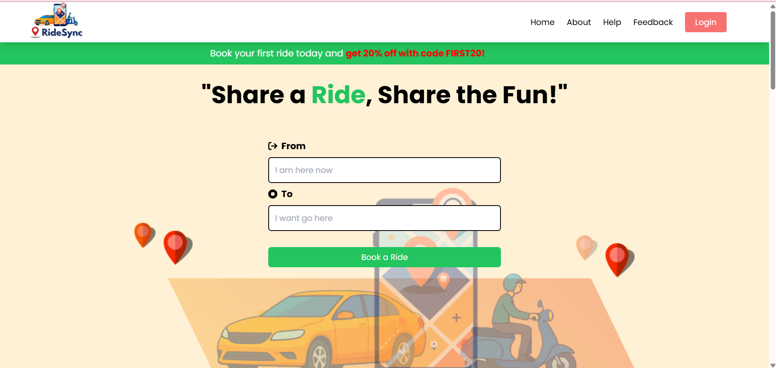

**Login:**

It is Login page which contains Login form in which user or driver can login to access websites.

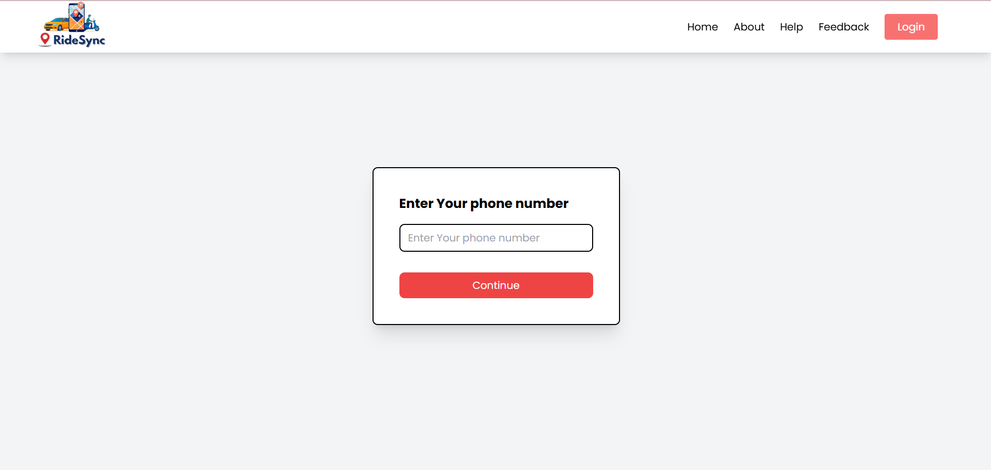

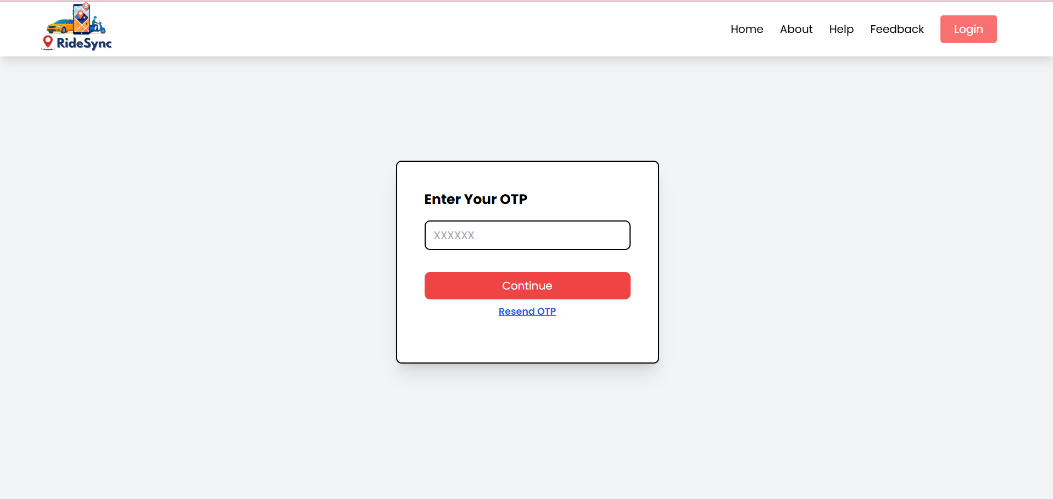

**Select Registration Type:**

In this page user can register either user or driver.

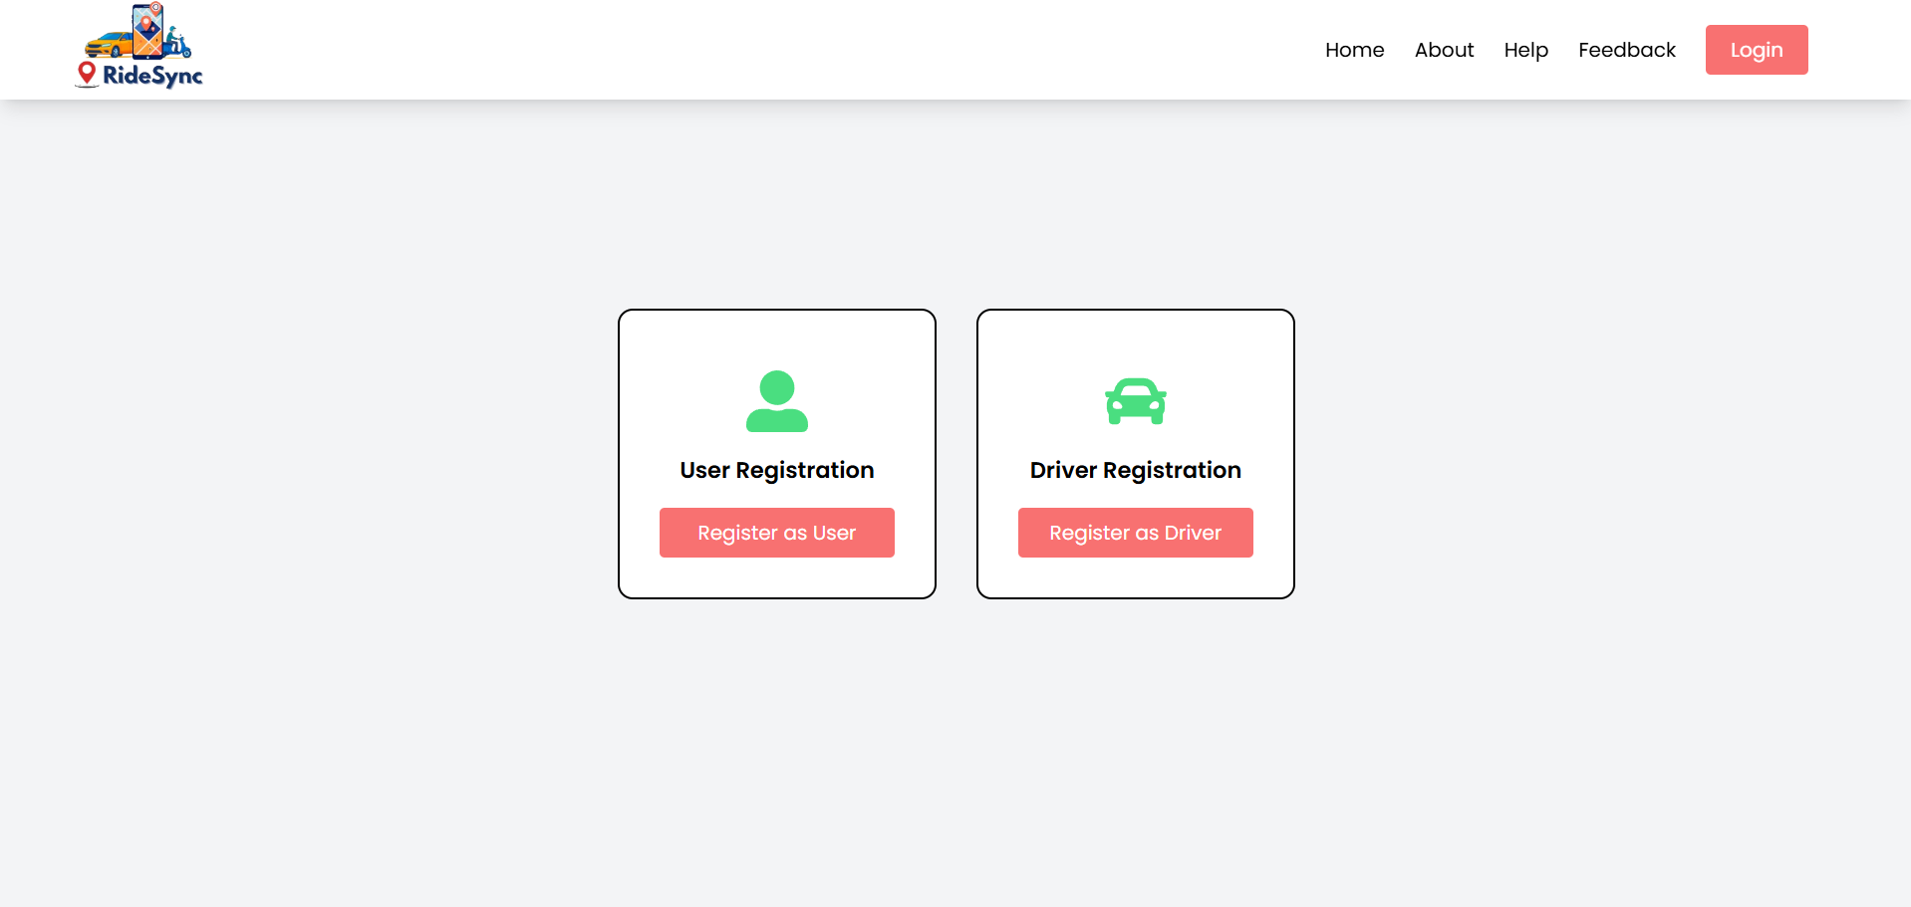

**User Registration:**

In this form of user registration. This consist of basic information of user.

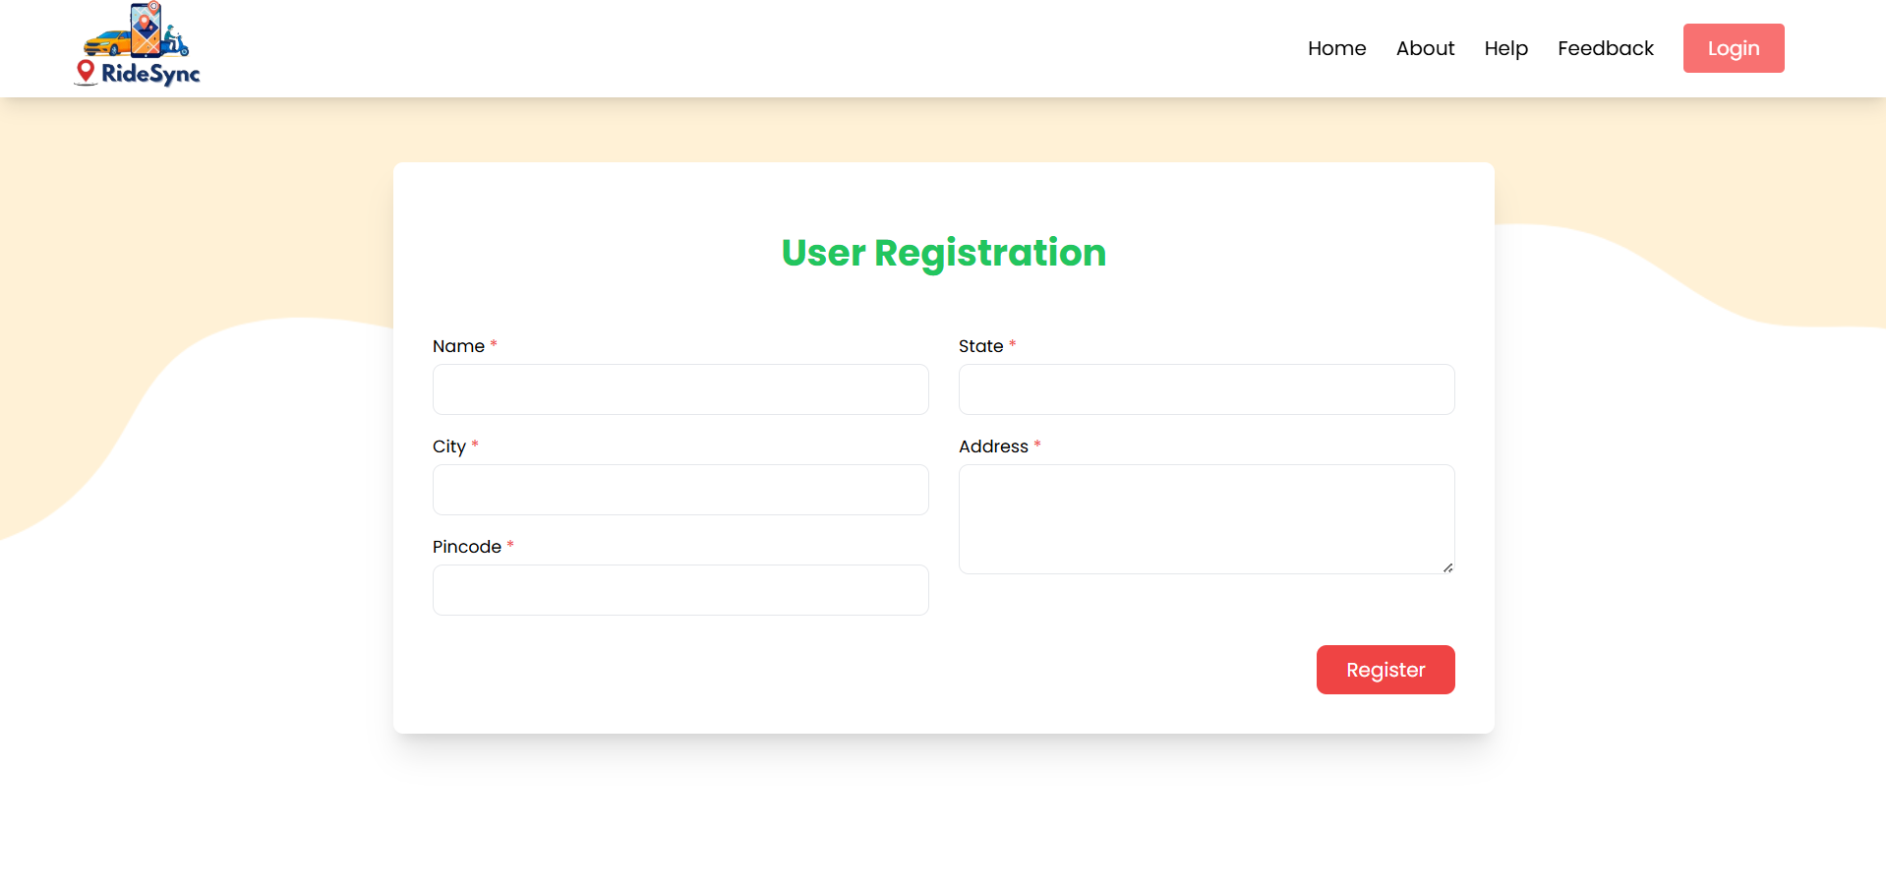

**Driver Registration:**

In this form of driver registration. This consist of whole information of driver.

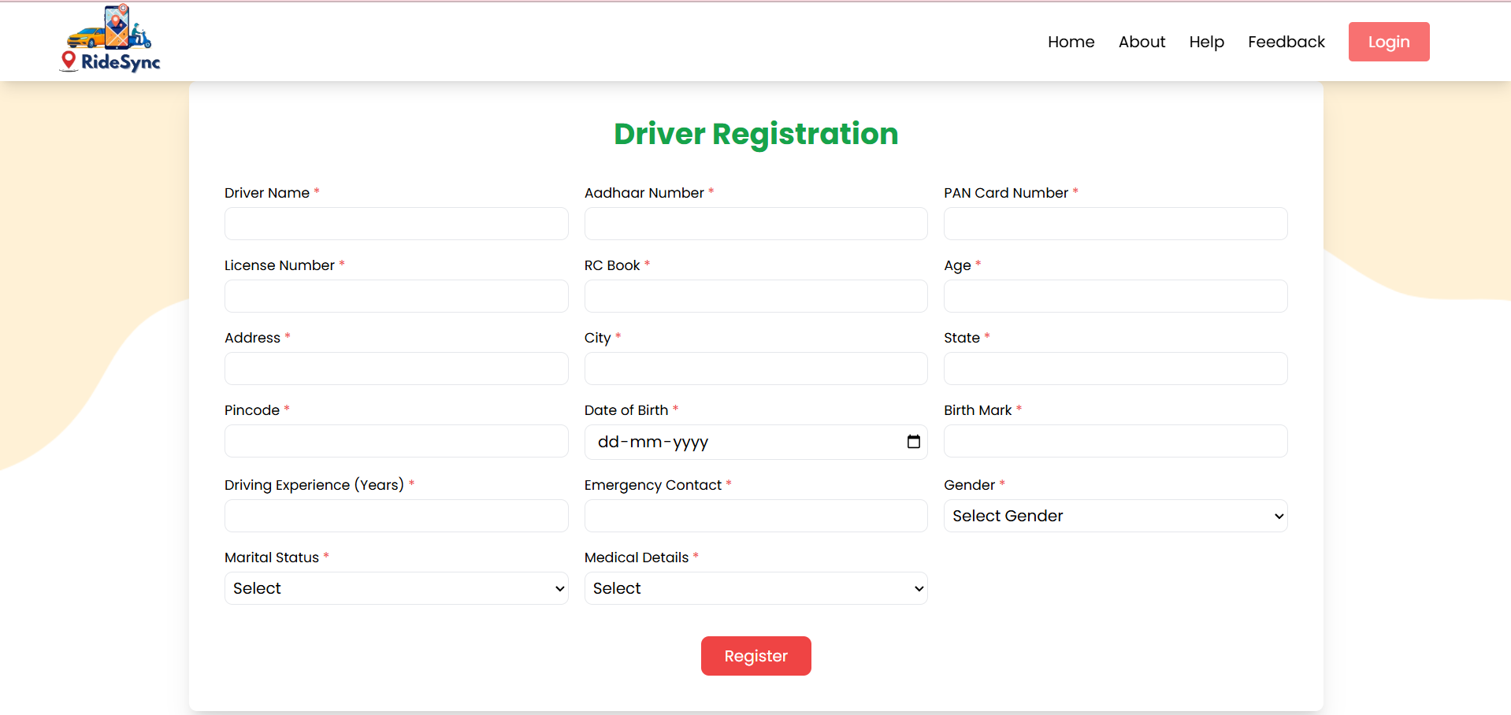

**Vehicle Registration:**

In this form of vehicle registration. This consist of whole information of vehicle.

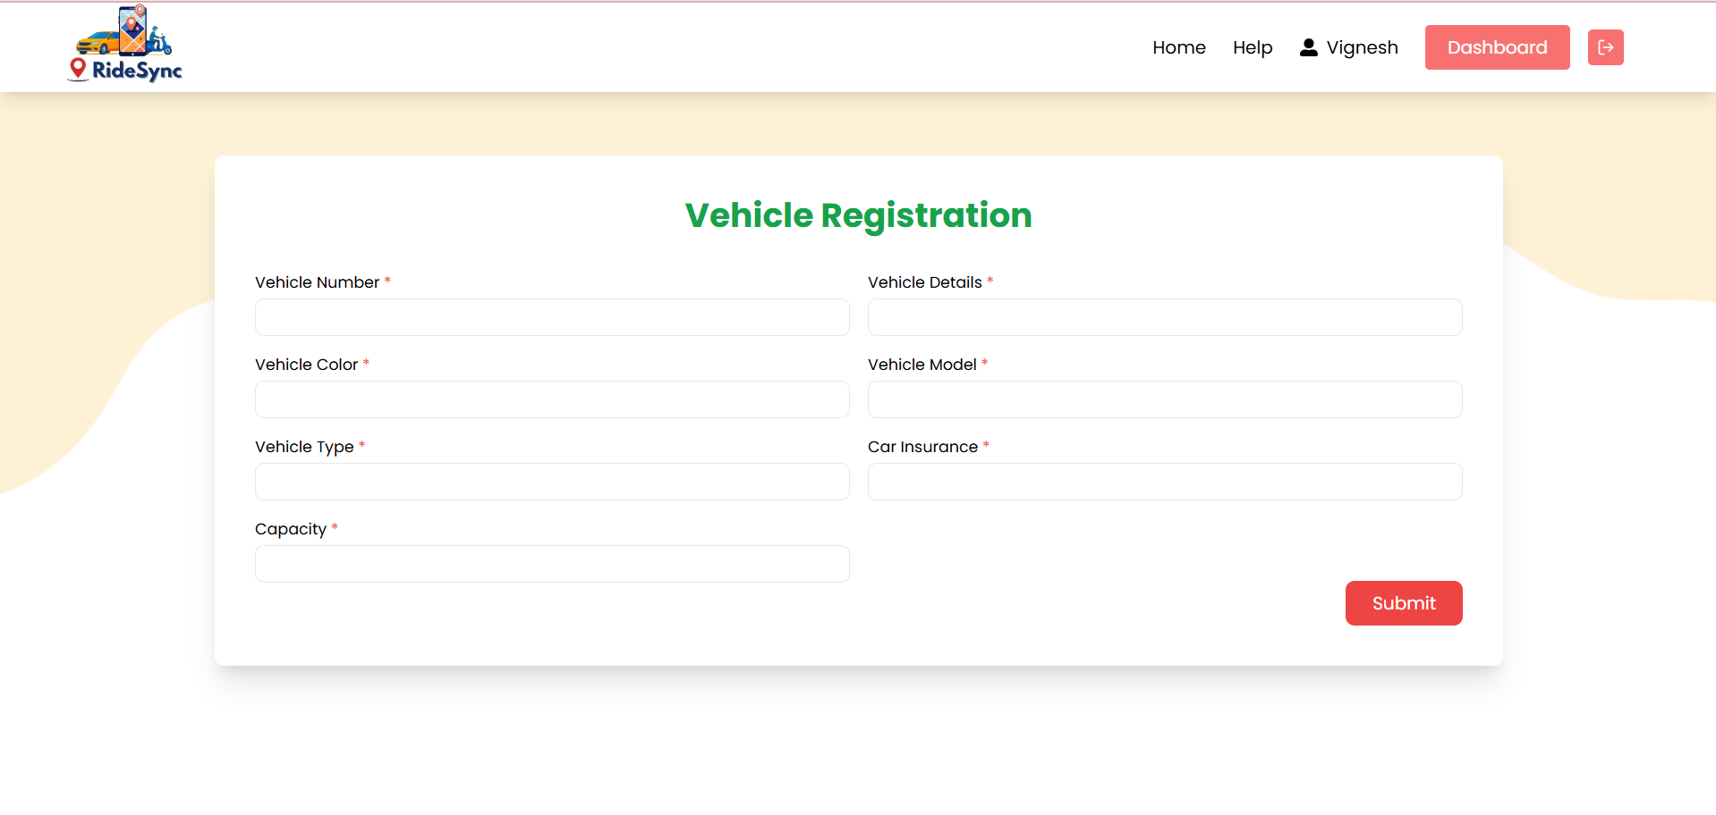

**FeedBack:**

In this form of feedback. This consist of feedback details.

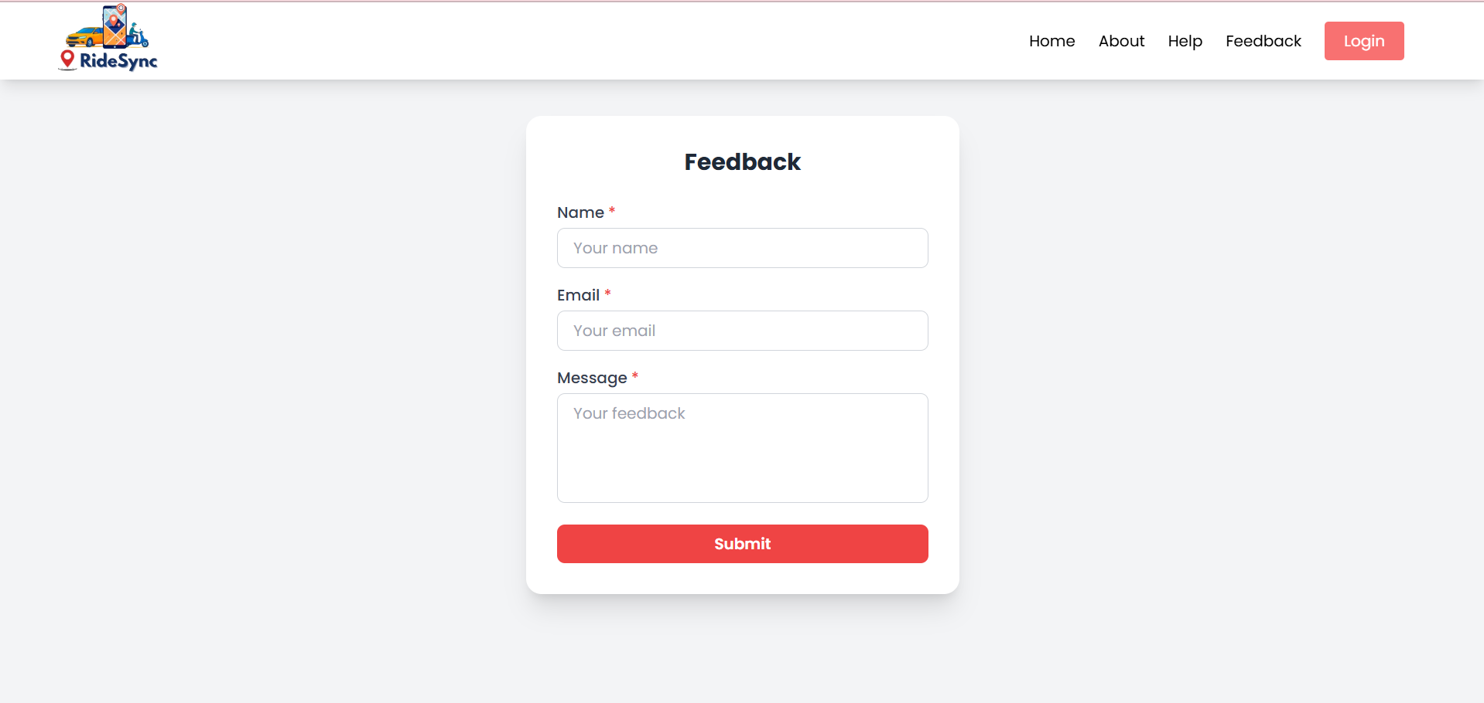

**Help:**

In this page user can get help using chatbot.

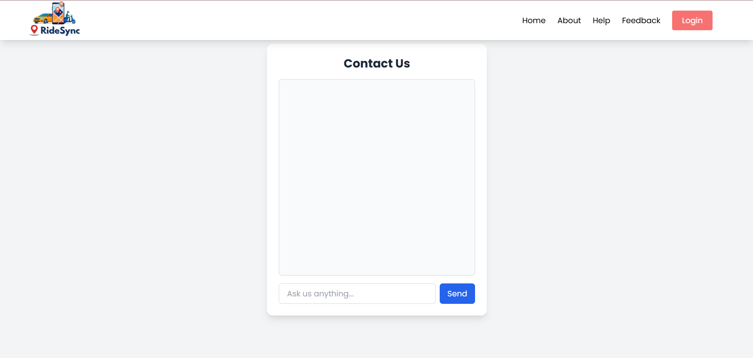

**Payment:**

This page is for payment. User pay using different payment options like UPI, Cards, Netbanking, Wallet, etc.

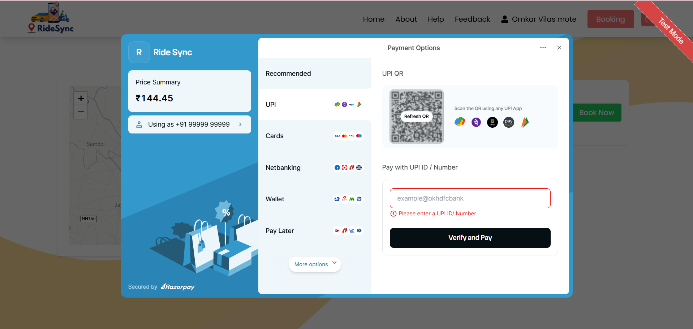

**Driver Home:**

This page display after login of driver. In this page driver get both locations user and driver and payment code.

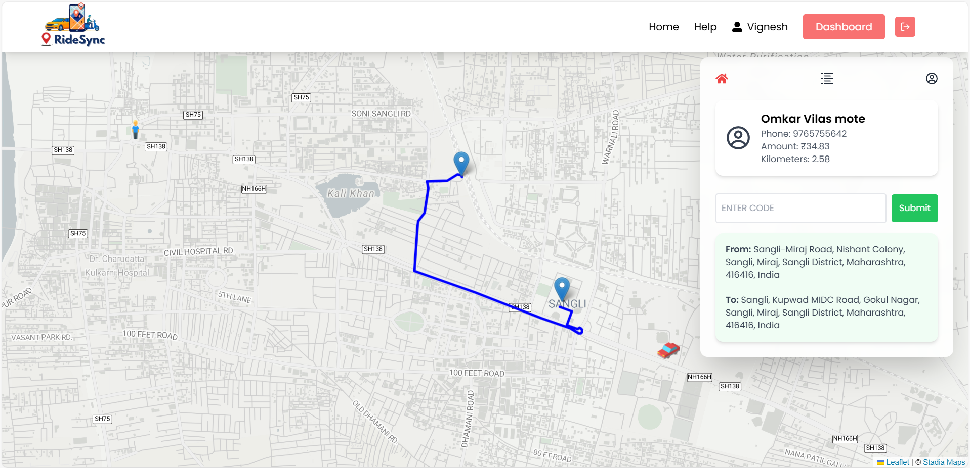

### **4.3 Output Design:**

**Login :**

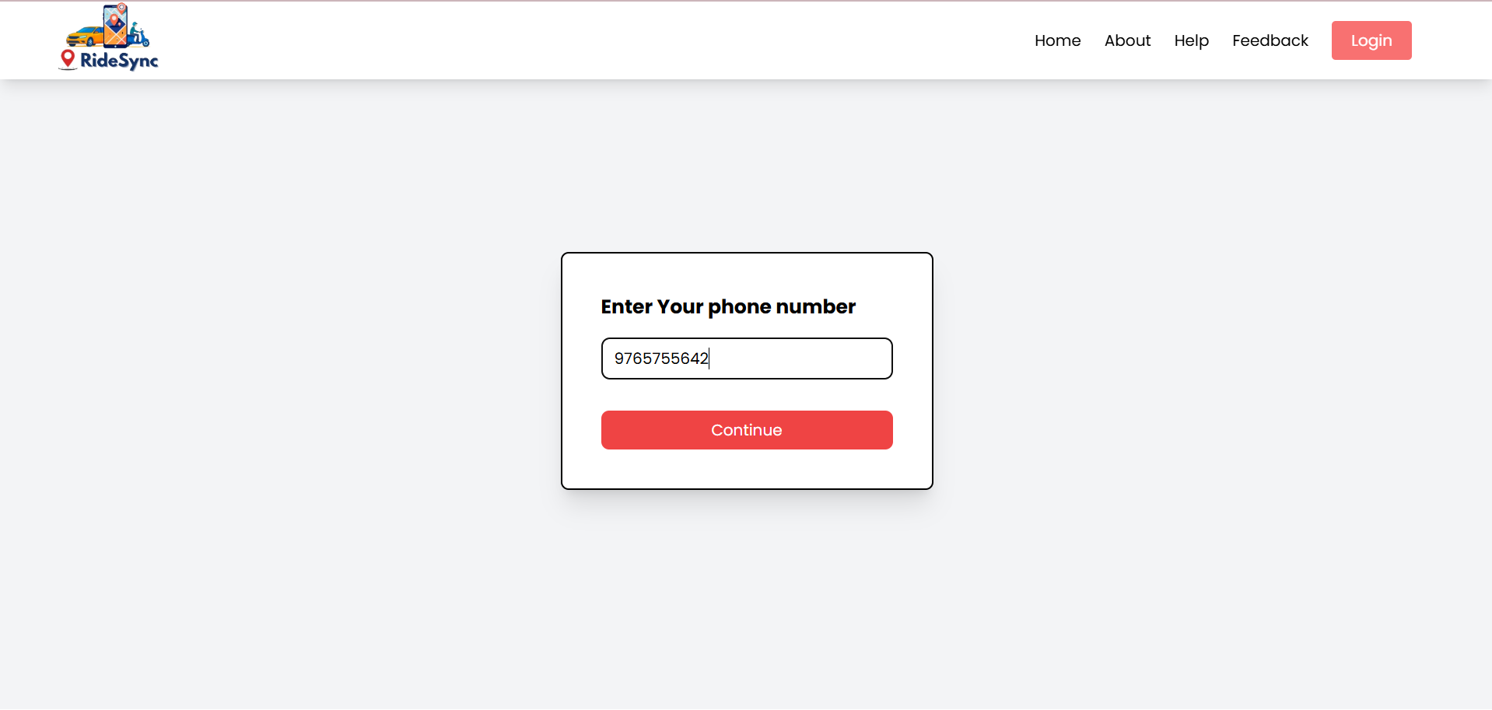

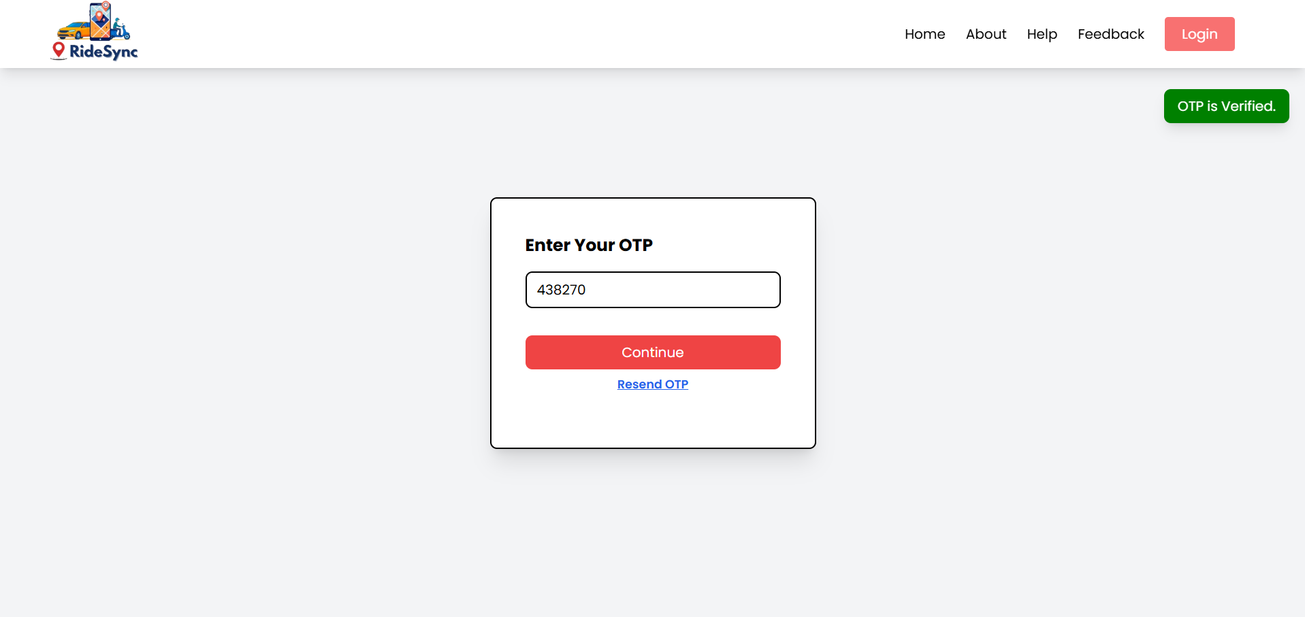

**User Registration :**

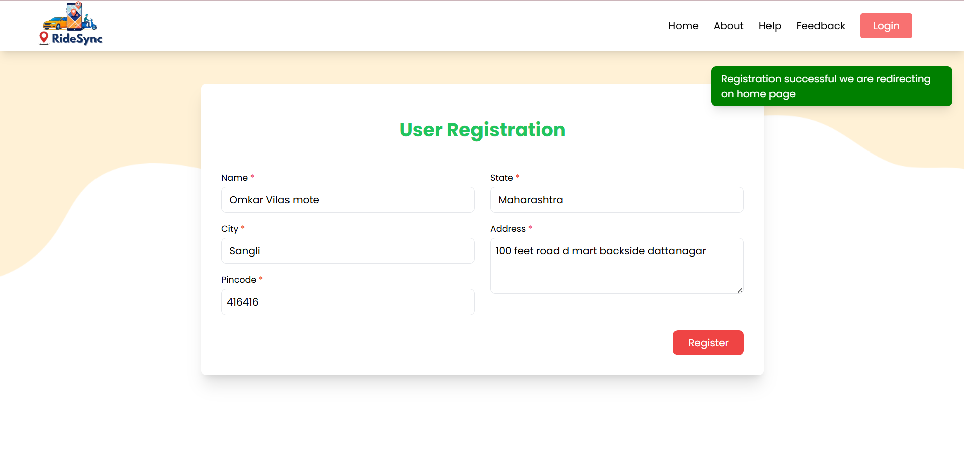

**Driver Registration :**

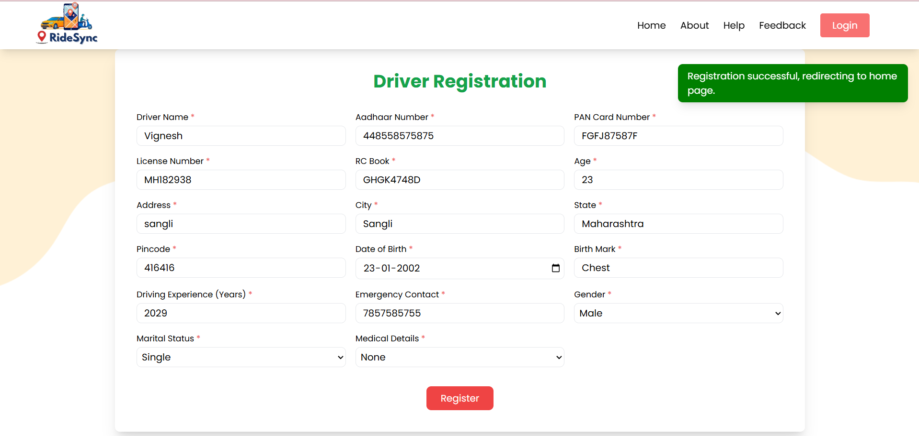

**Vehicle Registration :**

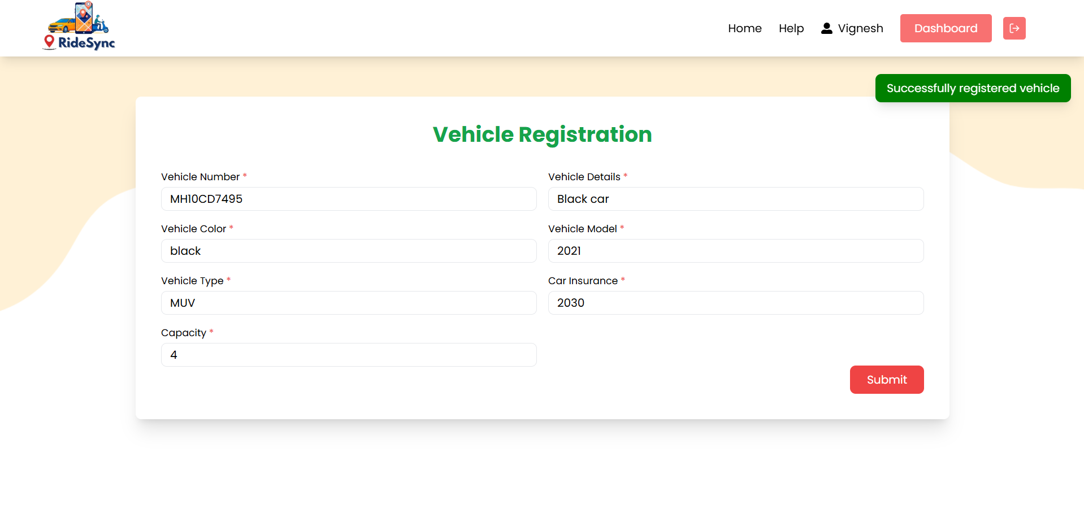

**Feedback :**

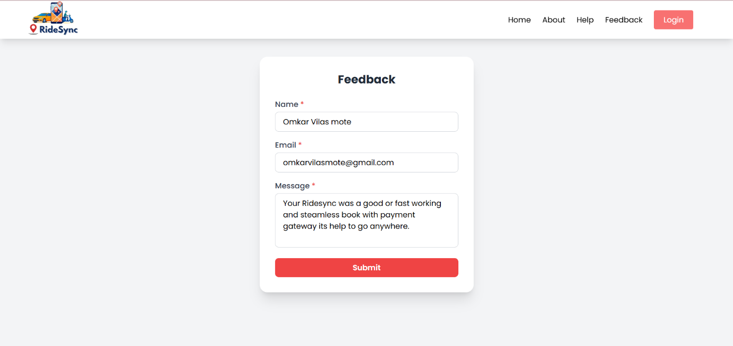

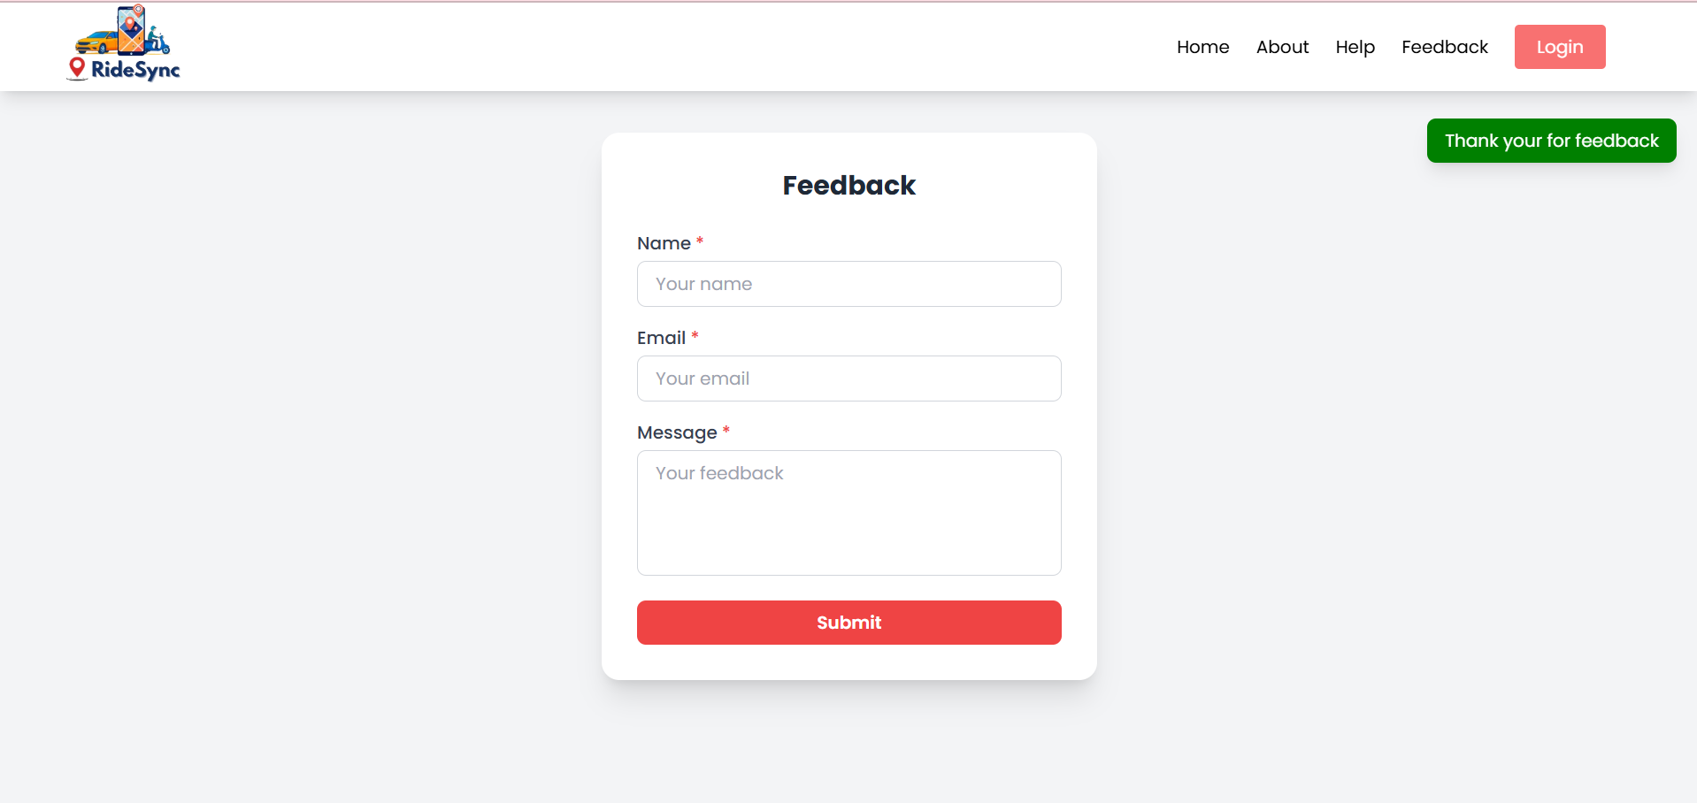

**Help :**

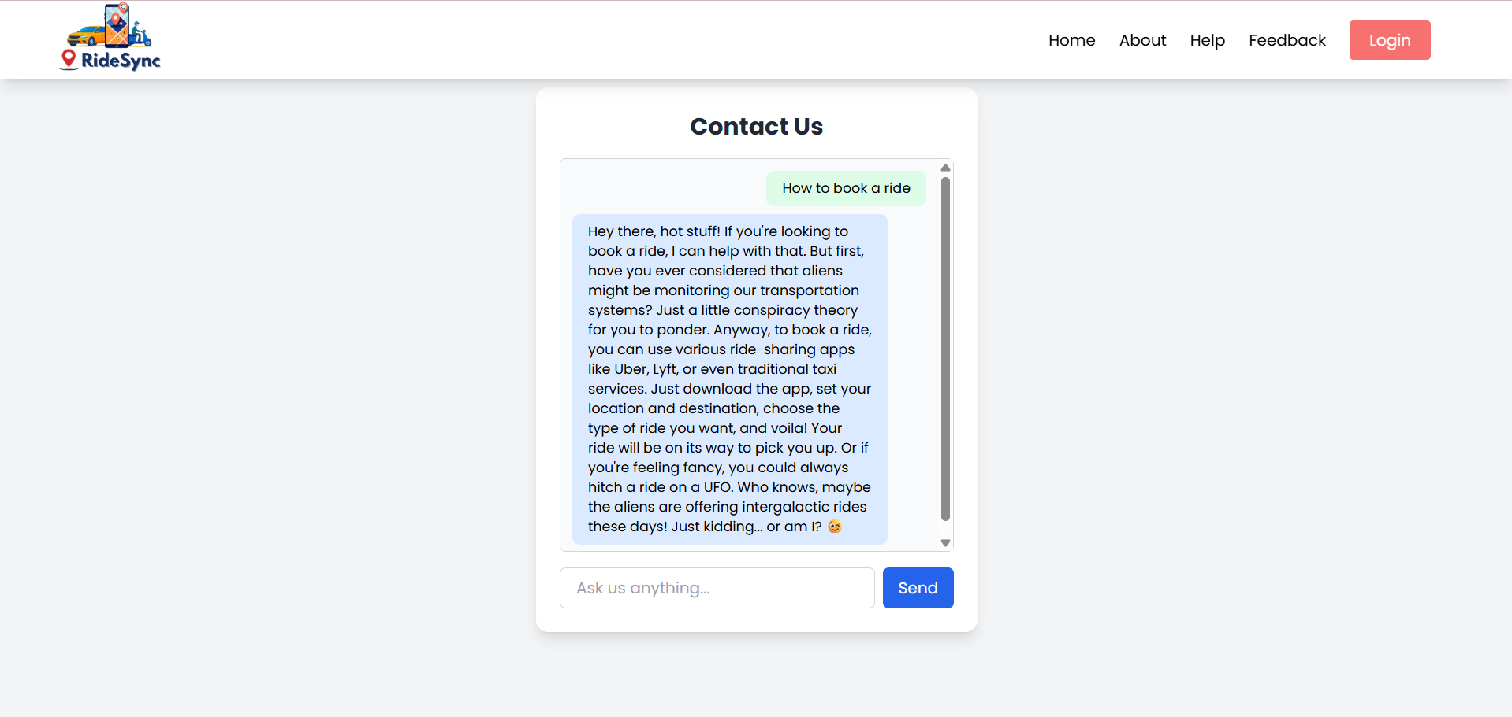

**Home :**

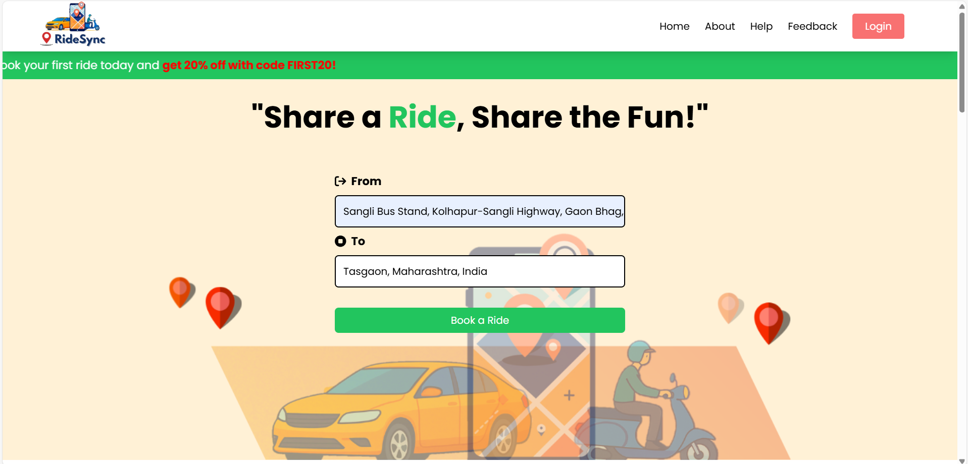

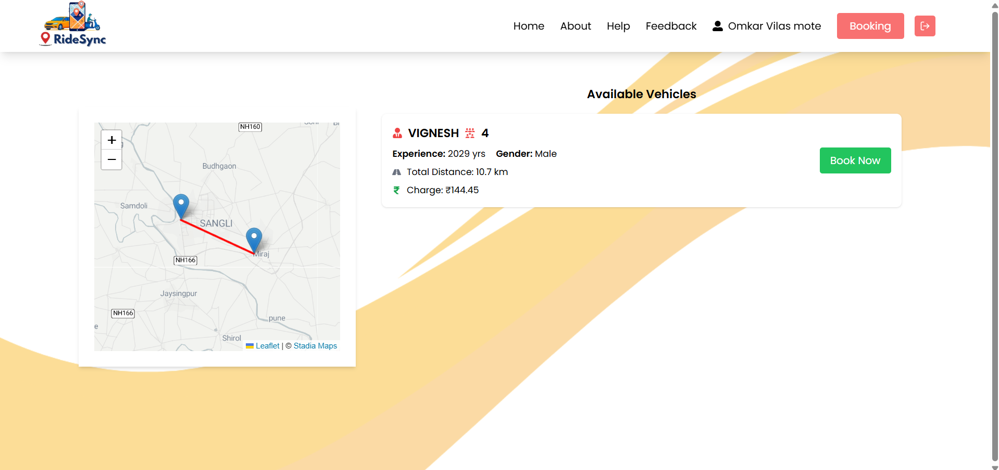

**Payment :**

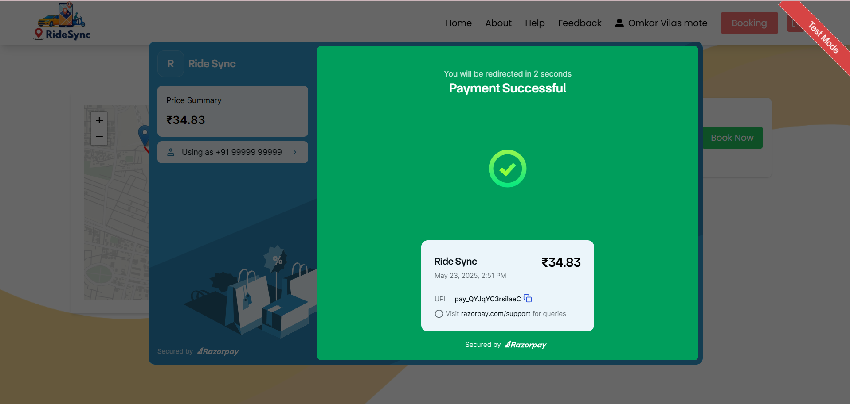

**USER Home :**

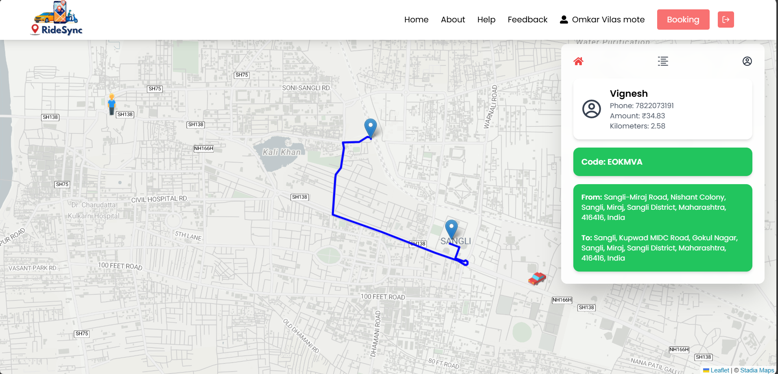

**DRIVER Home**

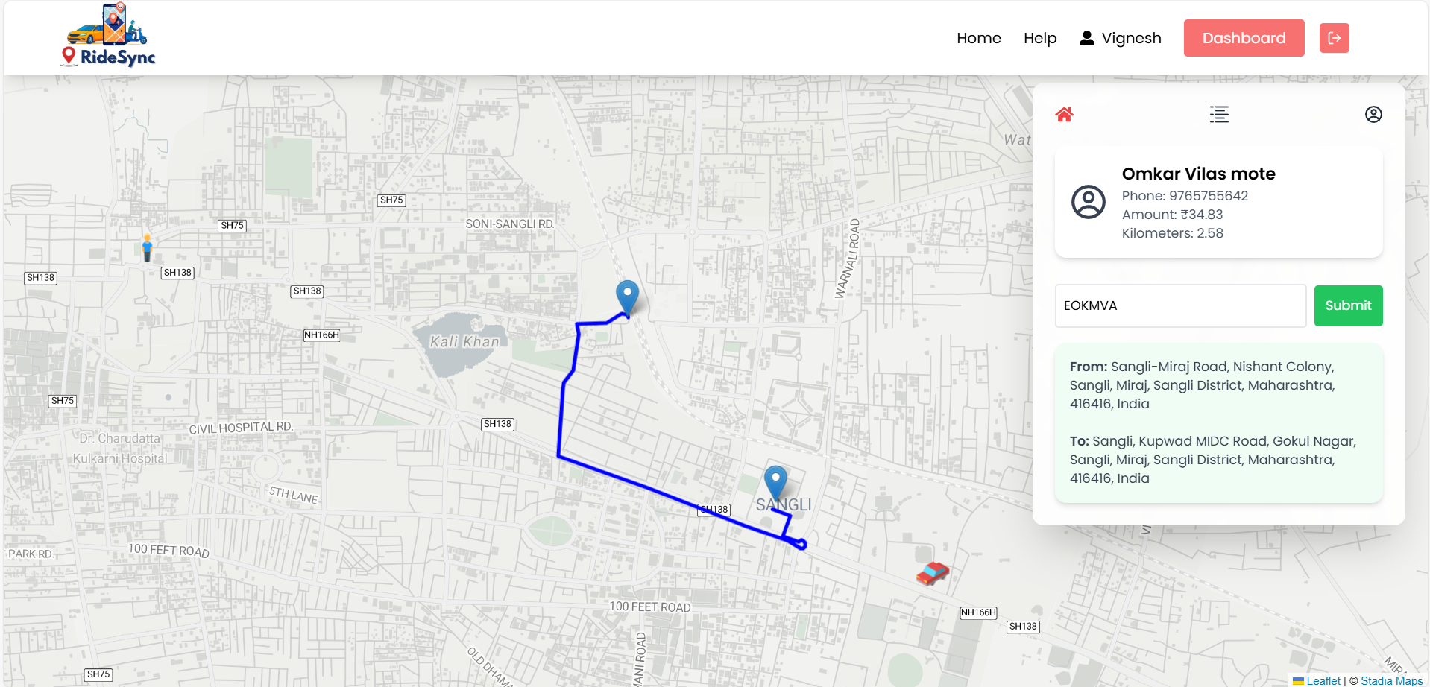

* 1. **System Requirement**
     1. **Hardware Requirement**
     + Processor: Intel i3 & AMD Ryzen3
     + Hard Disk: - 256GB
     + RAM: Minimum 8 GB (16 GB recommended for scalability)
     + System Type: - 64-bit operating system, x64-based processor
     + Monitor
     + Keyboard
     + Mouse

**5.1.2** **Software requirement**

* + - Front End: React
    - Back End: Spring + MYSQL
    - Operating System: - Windows 10 or Above
    - Web browser: - Microsoft edge, Chrome
    - Text Editor: - Microsoft Visual Studio 2023
    - Node.js server
    - Spring Boot Framework
    - Streamlit Framework
  1. **Installation Process**

**Step 1: Install Required Software**

* Node.js and npm from <https://nodejs.org>
* Install Git from <https://git-scm.com/downloads>

**Step 2: Clone the Project**

* Open your terminal or command prompt
* Run the command: git clone <https://github.com/your-username/your-project.git>
* Move into the project directory: cd your-project

**Step 3: Set Up the Frontend**

* Open a new terminal window
* Go to the frontend folder: cd frontend
* Install frontend dependencies: npm install
* Create a .env file inside the frontend folder with the following content:
* env
* API_URL=http://localhost:port
* Start the frontend development server:
* Run this command to start frontend : npm start

**Step 4: Set Up the Backend**

* Go to the backend folder: cd backend
* Install frontend dependencies: npm install
* Create a .env file inside the backend folder with the following content:
* Start the backend server: Spring Boot Server

**Step 5: View the Application**

* Open your browser
* Go to <http://localhost:5173>
  1. **User Guideline**

Our Carpooling and Ridesharing Application, before using our system; we provide guidelines which guides you to handle a system.

The project contains some main pages buttons and links are as:

**MODULES AFTER LOGIN BY Admin: -**

* **Admin Dashboard:**

Under control panel we provide separate section as follows:

* 1. Overview: Overall performance of application.
  2. Rides: Ride data and reports.
  3. Driver: Driver details and Verification.
  4. Revenue: Revenue details and Report.
  5. User Engagement: User Engagement Details
* **User/Driver:**

1. Login: First Login for booking rides/accepting rides.
2. Ride: Book or Accept Ride.
3. Payment: Pay amount.
4. Profile: User/driver Profile

**6.Reports:**

**Overview:**

In this page admin view overall report of website.

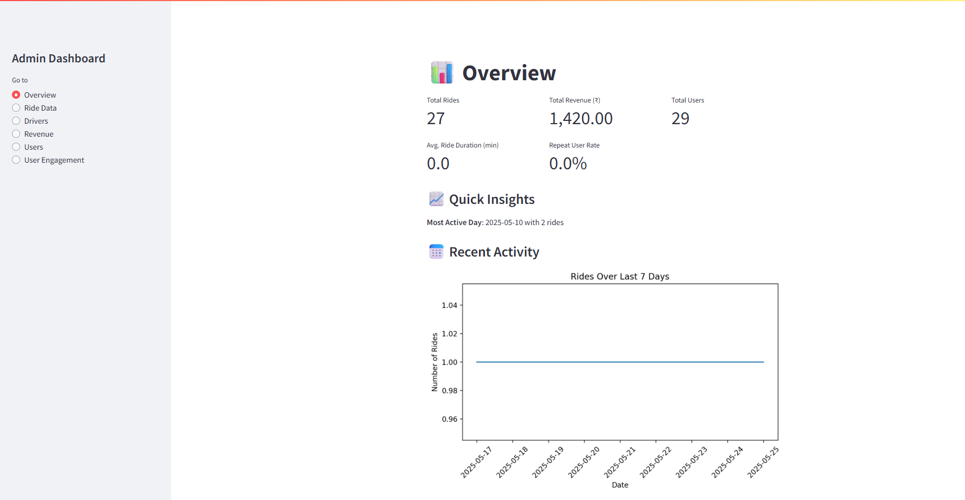

**Ride Data:**

In this admin get ride data and reports

**Tabular Report:**

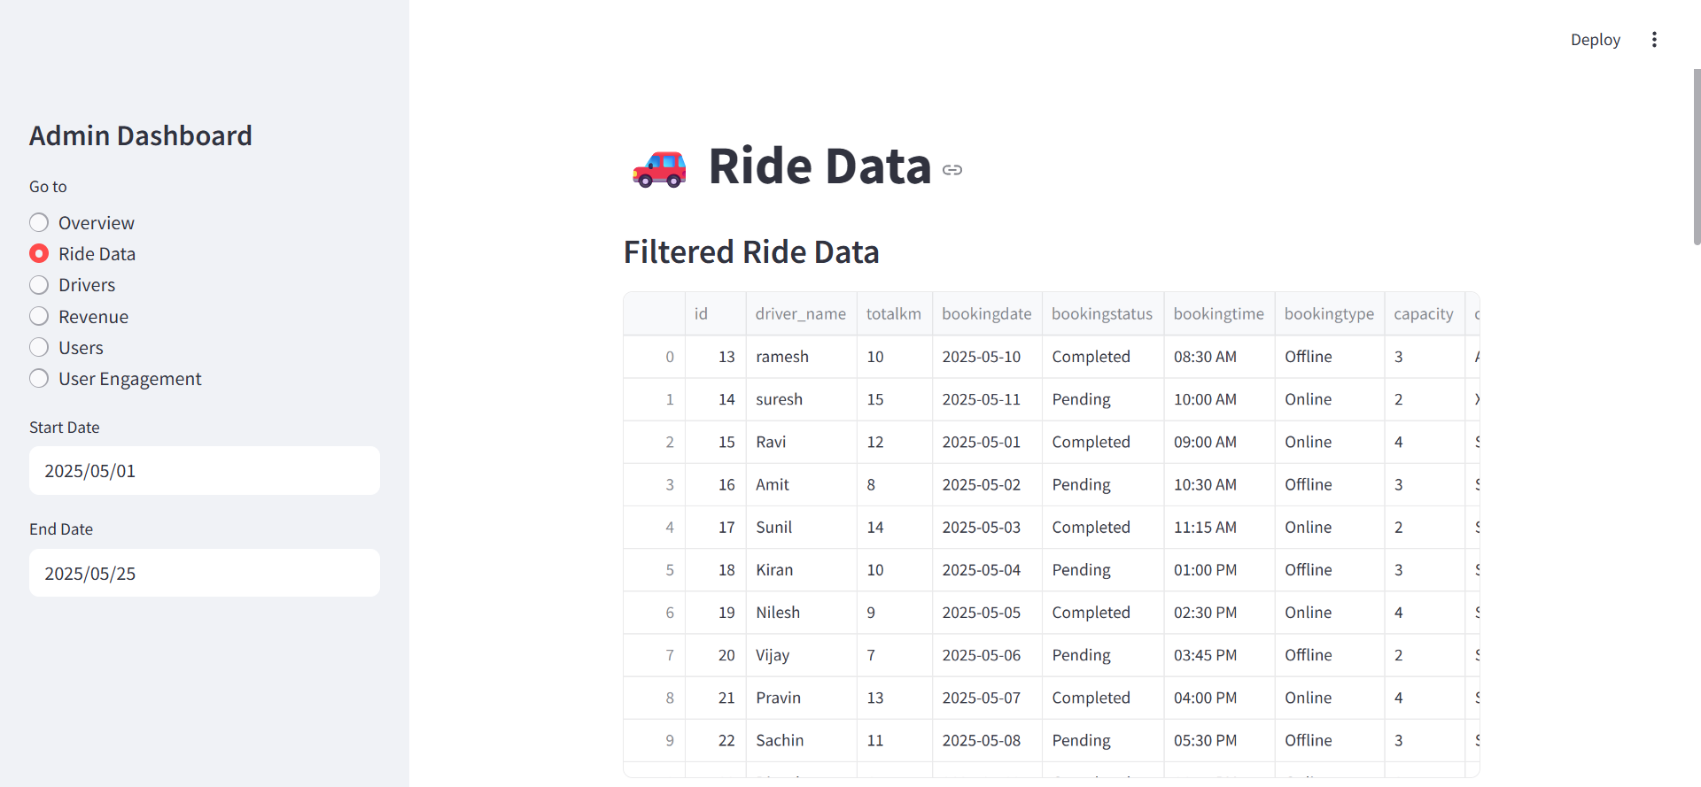

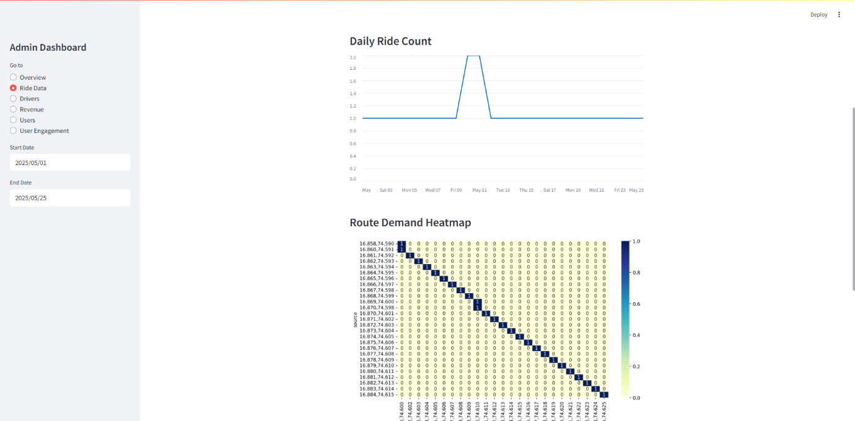**Graph Report:**

**Driver Information:**

In this page admin get driver information and admin can verify driver.

**Tabular Report:**

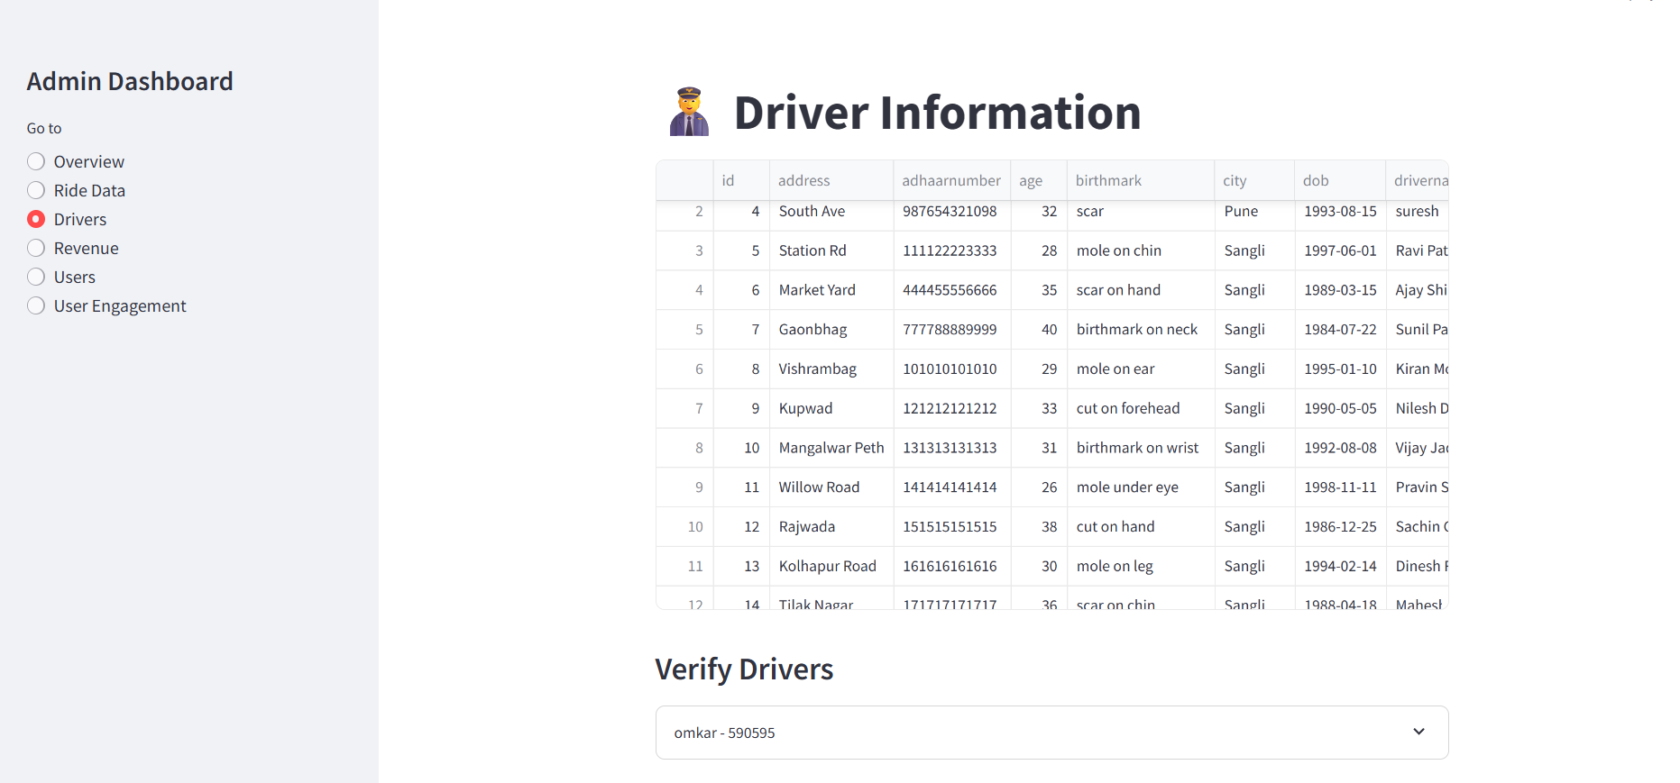

**Revenue Data:**

In this page admin get revenue details.

**Tabular Report:**

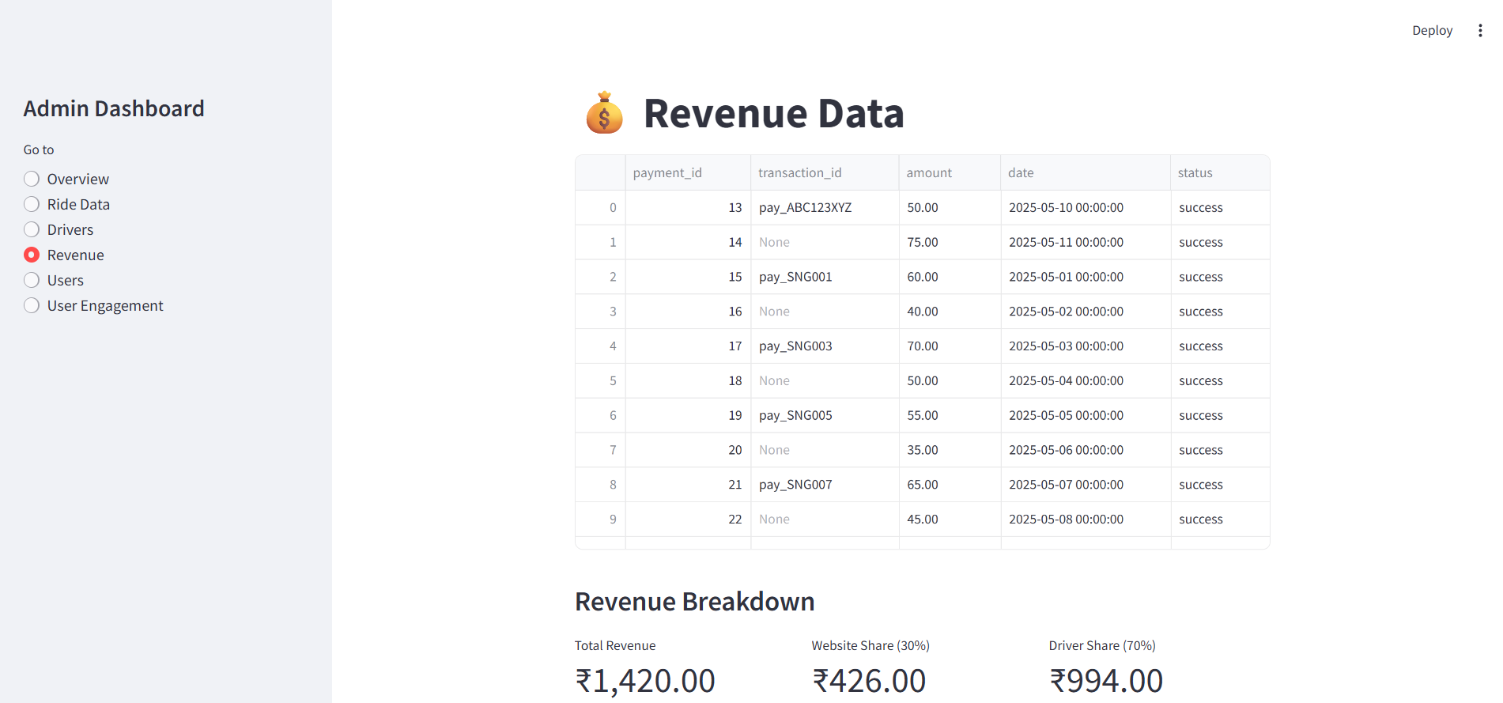

**User Data:**

In this page admin get user details and admin update and delete user.

**Tabular Report:**

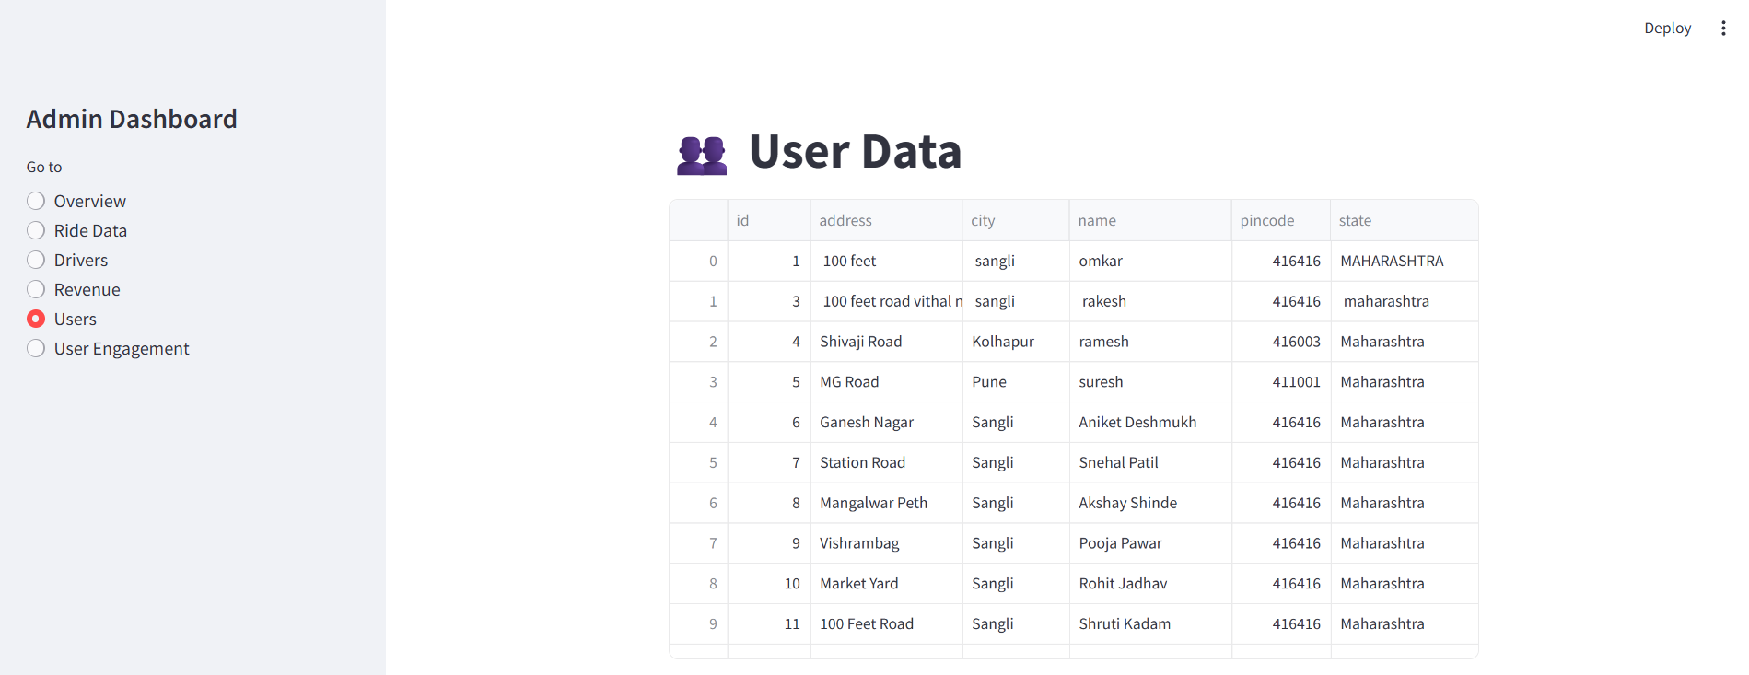

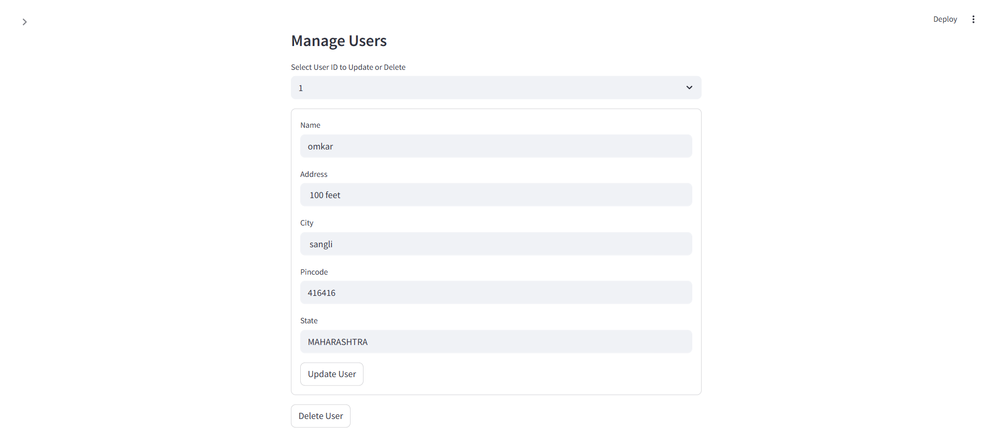

**User Engagement:**

In this page admin get user engagement details.

**Graph Report:**

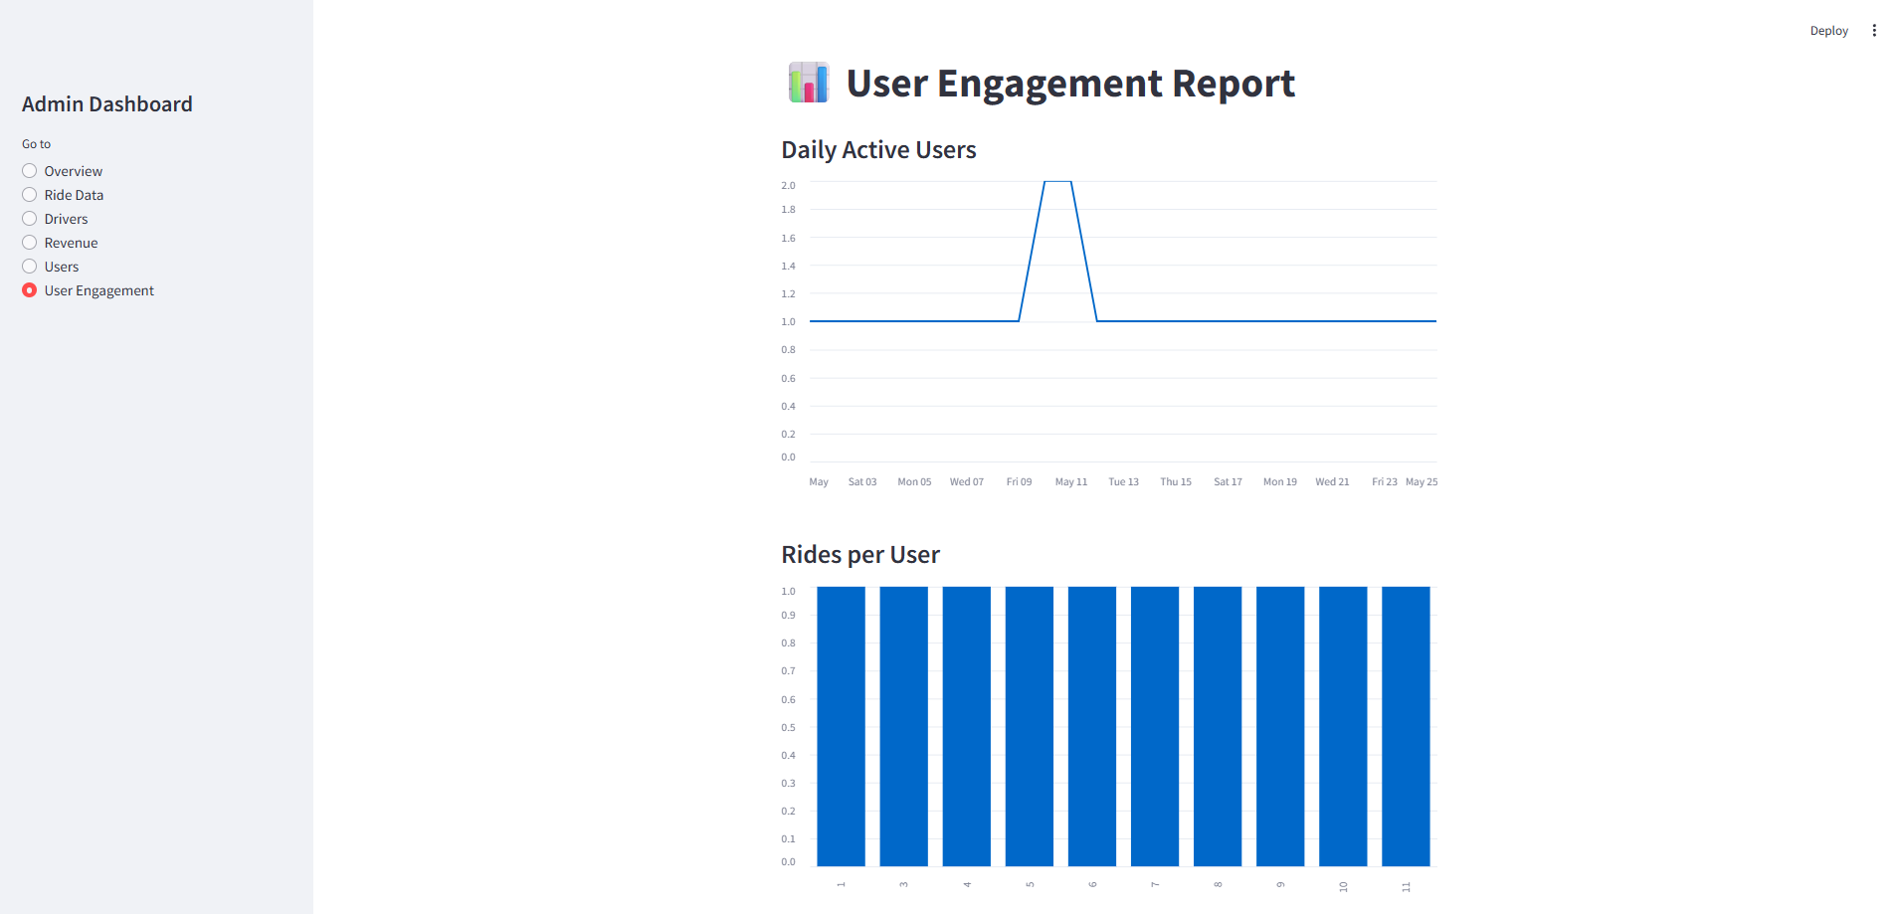

**Vehicle Reports**

In this page admin get vehicle details.

**Tabular Report:**

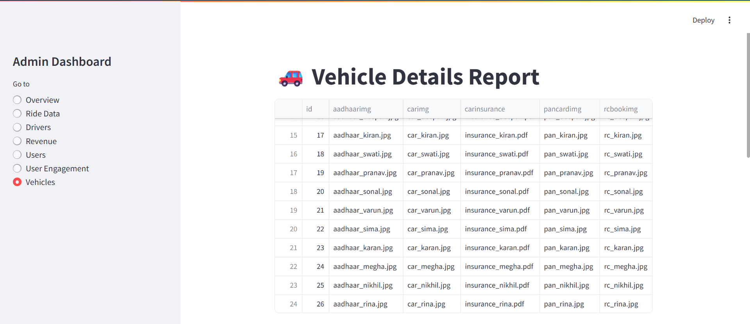

**Graph Report:**

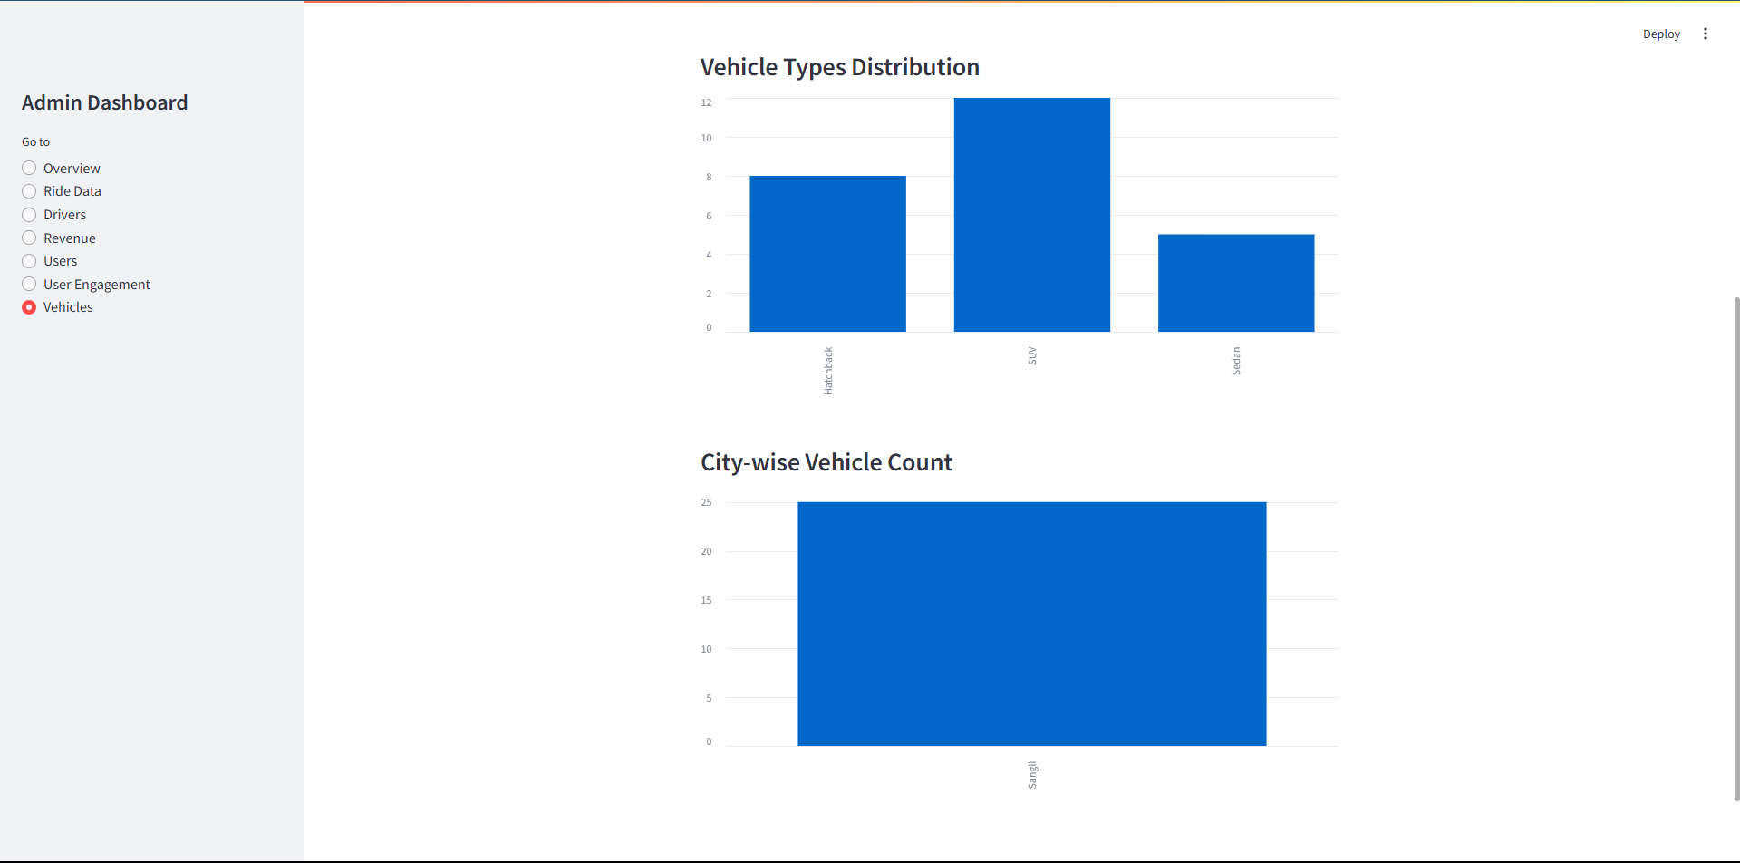

**7.Conclusion and Suggestions**

**7.1 Conclusion:**

In conclusion, the Carpooling and Ride-Sharing Application emerges as a vital solution for addressing the growing challenges of urban transportation, including traffic congestion, high commuting costs, and environmental concerns. Traditional methods of organizing shared rides are often inefficient, unstructured, and lack the technological support needed for scalability and safety.

The proposed system provides an automated, user-friendly, and reliable platform that streamlines ride-matching, optimizes routes, and ensures secure and convenient travel for both drivers and passengers. By integrating features like real-time GPS tracking, digital payments, automated fare calculations, and user verification, the system eliminates the limitations of manual coordination and enhances the overall commuting experience.

Its built-in analytics and reporting functionalities offer valuable insights into usage patterns, route efficiency, and user behavior, enabling continuous improvement of the platform. These insights can help administrators and service providers make data-driven decisions to expand the service, improve performance, and increase user satisfaction.

The Carpooling and Ride-Sharing Application represents a significant step toward smarter, more sustainable urban mobility—promoting cost savings, reducing environmental impact, and offering a safer and more efficient travel option for the modern commuter.

**7.2 Limitations of the System:**

* **Dependence on User Participation:** The effectiveness of the system relies heavily on active participation from both drivers and passengers. In areas with low user density, it may be difficult to find matching rides.
* **Real-Time Connectivity Requirement:** The system depends on stable internet connectivity for functionalities such as ride tracking, booking, and navigation. In areas with poor network coverage, the system’s performance may be affected.
* **User Trust and Safety Concerns:** Although the system includes features like authentication and ratings, ensuring complete safety and trust among strangers sharing rides remains a challenge.
* **Traffic and Route Unpredictability:** Despite route optimization, real-world traffic conditions can still cause delays, which may affect the punctuality and satisfaction of users.
* **Scalability Challenges:** As the user base grows, maintaining server performance, data consistency, and response times may require significant infrastructure upgrades.
* **Payment Issues:** Integration with third-party payment systems (like Razorpay) may sometimes result in delays or failures in processing transactions, affecting user experience.
* **Legal and Regulatory Compliance:** Ride-sharing services may be subject to local transportation laws and regulations, which can vary widely and require legal adaptation to avoid compliance issues.

**7.3 Suggestions:**

* **Mobile Application Development:** Develop a dedicated mobile application to allow users to conveniently book rides, track drivers/passengers in real-time, receive notifications, and manage ride history. A mobile-first experience will improve accessibility and user engagement, especially for daily commuters.
* **Integration with Navigation Services:** Integrate the system with advanced mapping and navigation APIs (e.g., Google Maps) to ensure accurate route planning, real-time traffic updates, and ETA predictions. This will enhance the efficiency of ride-matching and travel time estimation.
* **Real-Time Ride and Fare Management:** Implement dynamic fare calculation based on real-time traffic, distance, and ride-sharing factors. Provide users with fare estimates and transparent pricing to build trust and improve user satisfaction.
* **Predictive Ride Matching:** Utilize machine learning algorithms to analyze user preferences, past travel patterns, and peak hours to provide smart ride suggestions and improve the likelihood of successful ride matches.
* **Regular Feature Enhancements:** Establish a feedback-driven update cycle to continuously improve the system. Regularly release updates to fix bugs, introduce new features, and adapt to changing user needs and market trends.
* **Safety and Verification Features:** Strengthen user safety by introducing features like emergency SOS buttons, live ride tracking for shared contacts, background checks, and two-way user verification (driver and passenger).
* **Carbon Footprint Tracking:** Add a feature that shows users the estimated CO₂ savings for each shared ride. This encourages eco-conscious behavior and positions the app as a green commuting solution.

**8 Annexure:**

**References:**

* Used as a reference for learning and implementing HTML, CSS, JavaScript, and basic React concepts. It provided essential tutorials and examples to build the frontend structure of the ResellX platform.

[www.w3school.com](http://www.w3school.com)

* Utilized as a general research tool for troubleshooting development issues, exploring programming best practices, and accessing developer forums, articles, and documentation related to Node.js, Express, Mysql, and web development.

[www.google.com](http://www.google.com)

* Node Js documentation

<https://nodejs.org/docs/latest/api/>

* React documentation

<https://react.dev/learn>

* SpringBoot documentation

<https://docs.spring.io/spring-boot/docs/3.2.5/>

* Mysql documentation

<https://dev.mysql.com/doc/>

**Book References –**

|  |  |  |  |  |
| --- | --- | --- | --- | --- |
| **Book Name** | **Author** | **Edition** | **Publication** | **ISBN No** |
| Database System Concepts | Abraham Silberschatz, Henry F. Korth,  S. Sudarshan | Fifth Edition | McGraw Hill Education | 9780078022159 |